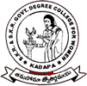
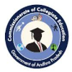
SKR & SKR GOVERNMENT COLLEGE FOR WOMEN (A),
Kadapa
Re-Accredited “B” by NAAC
Affiliated to Yogi Vemana University

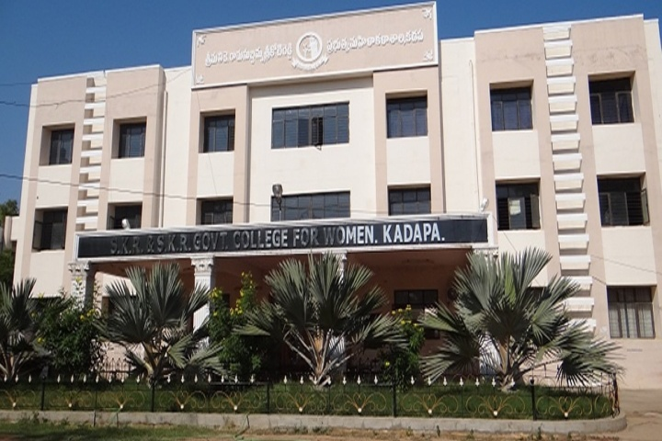
NEWS LETTER
AUGUST
2022
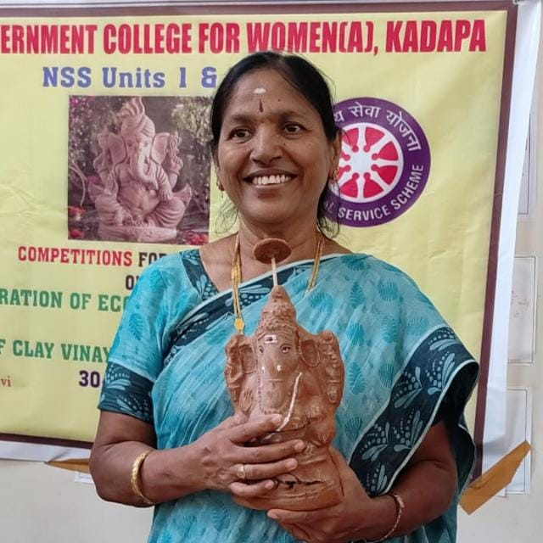
Principal’s Message:
With a pleasant environment and adequate Learning ambience
SKR & SKR Govt. College for Women(A), Kadapa is imparting
Quality education with values through blended teaching-learning
and reaching the expectations of the stakeholders in empowering
the women students. Good education is the foundation for
secure, prosperous and bright future. Our students, the learners
of today are well trained to face the challenges of highly
Dr P. SUBBA LAKSUMMA,
M.Com, M.Phil, Ph.D.
Principal
competitive future.
We have well experienced, qualified and highly motivated
faculty, staff and skill development trainers to make sure that
our students enhance their thinking capacity, analytical frameworks
interpersonal skills, communication skills and technical skills which will mould them into well rounded technocrats. Also our autonomous status allows us to constantly review the curriculum and update as per the industry requirements which ensure that all our students are industry ready when they leave our institution. Outcome Based teaching learning process, academic discipline, innovative practices in the laboratory, project based subject learning, bridge course, remedial classes, research and development activities, industry linked training and internship opportunities, various skill training for facing interviews, personality development programmes and active participation in the various seminars, conferences, activities for life skills, yoga and meditation, etc. In both curricular and co-curricular activities our students have been faring exceptionally well at various levels and upholding the prestige of the institution. INFLIBNET facility was yet again extended to all the students and staff of the college. Implementing Swachh Bharat, Jagananna Pachhathoranam, conducting awareness programmes and celebrating national importance programmes creates sense of responsibility in all stakeholders. The active role of statutory and non-statutory bodies, NCC, NSS, WEC, Anti Ragging Cell, Consumer club, Eco club, Alumni etc., enhance good administration and academic excellence of the institution. On its part, the Department of Collegiate Education, AP is extending constant support to the students by taking timely initiatives in providing employment through the conduct of job recruitment drives in the College. Being an excellent destination for quality education, SKR & SKR Govt. College for Women (A), Kadapa. with its veteran management, faculty and staff are contributing significantly to make the students to reach the pinnacle of prospective career.

VISION

To impart value based higher education for women students hailing from rural, economicallyinstable background and to bring in changes on par with the needs of the society particularly inthe context of globalization and to empower women students to contribute towards Nation Building
MISSION

To provide quality Education to women students, help them in acquiring knowledge, building self-confidence and positive thinking.
We aim at developing leadership qualities, communication skills and technical competencies.
To empower the women students towards self-reliance.
To strive for all-round development of the students.
OBJECTIVES
1. To strive for excellence in providing holistic education.
2. To create opportunities of learning with inclusiveness.
3. To promote continual learning with quality consciousness.
4. To encourage students to think innovatively.
5. To enhance self-confidence among the students.
6. To augment collective learning of teachers and students.
7. To expand the resource base for knowledge with linkages.
8. To use ICT extensively in the teaching-learning process.
9. To provide employable skills to make the students industry-ready.
10. To sharpen the creative faculties of students with reason and values.

CONTENTS
S. No. | NAME OF THE ACTIVITY | PAGE No.
1 | BoS meetings | 5-8
2 | Video Conference | 9
3 | Elocution competition, Guest Lecture | 10
4 | MLC visit, CPDC meeting | 11
5 | NCC farewell day celebrations | 12-13
6 | Tree plantation | 14
7 | 5 days Residential ToT programme | 15
8 | Azadi ka Amrit Mahotsav | 16-17
9 | Partition Horror Remembrance day | 19-20
10 | Independence Day celebrations | 21-24
11 | RJD Visit, Campus drive | 25
12 | Awareness programme and medical counselling | 26
13 | Awareness programme on Solar Energy | 27
14 | Academic Audit Day 1 | 28-31
15 | Academic Audit Day 2 | 32
16 | Academic Audit Exit meeting | 33
17 | Telugu Bhasha Dinotsavam | 35
18 | Ganesha Clay Idol Distribution | 36
Board of studies(bos) MEETINGS
BoS keeps track of the emerging trends and latest industry requirement, the global changes taking place in relation to the innovativeness etc and bring in the necessary changes into curriculum so that the curriculum is up to date addressing all current requirements.SKR & SKR Govt. College for Women (A), Kadapa is being an antonomous institution all the departments conducted Board of Studies meeting for the year 2022-23.
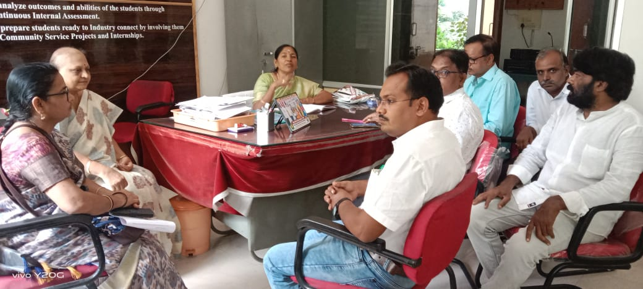  Dept of Chemistry BOS on 27.08.2022 | 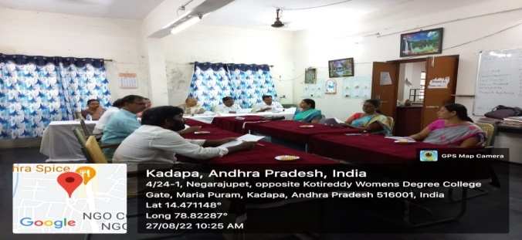  Dept of Chemistry BOS on 27.08.2022
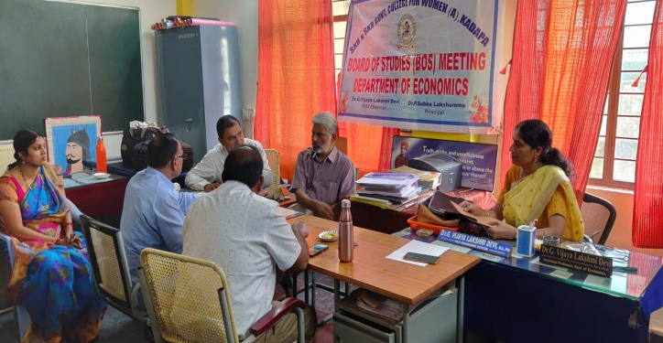  Dept of Economics BoS on 27.08.2022 | 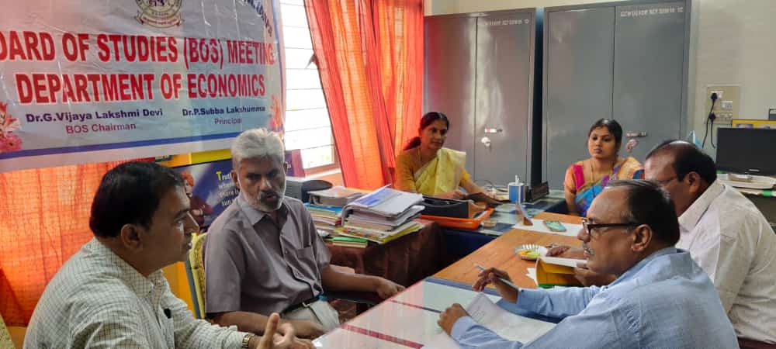  Dept of Economics BoS on 27.08.2022
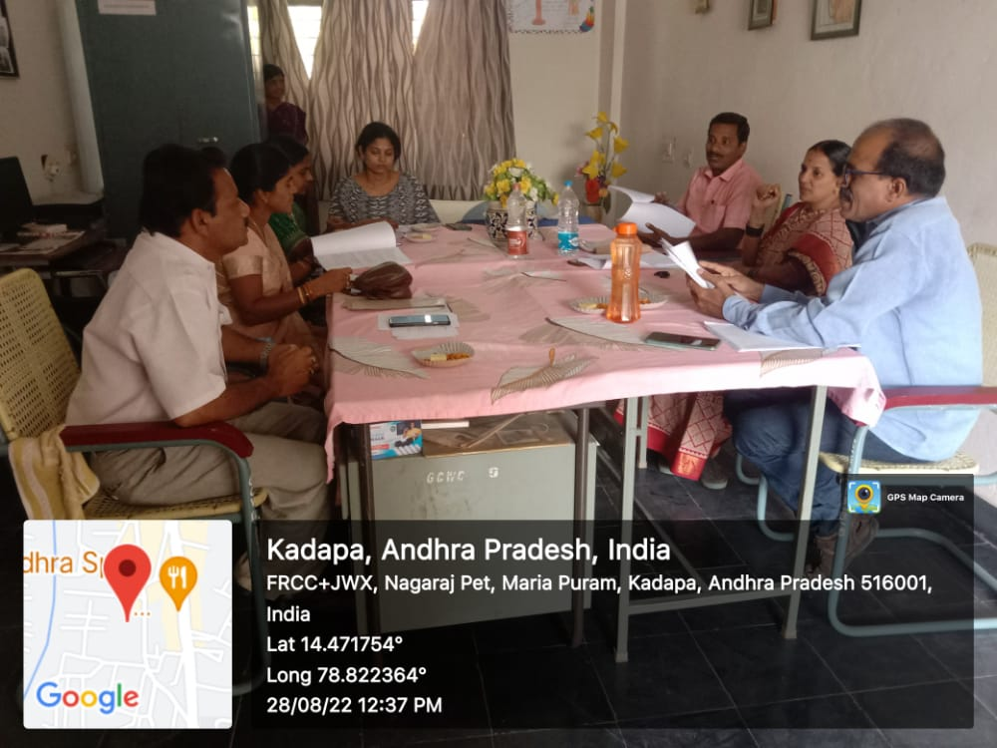  Dept of Mathematics BoS on 28.08.2022 | 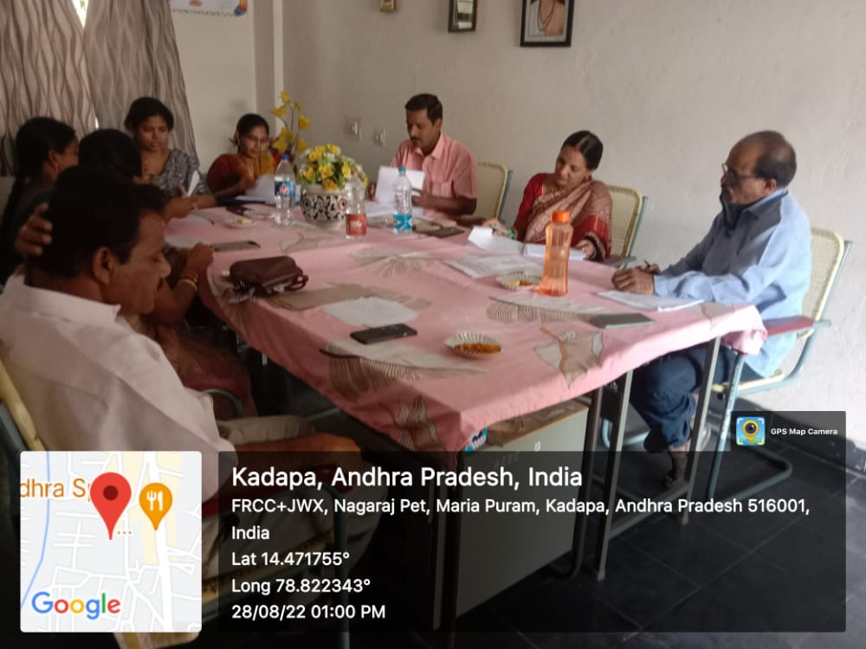  Dept of Mathematics BoS on 28.08.2022
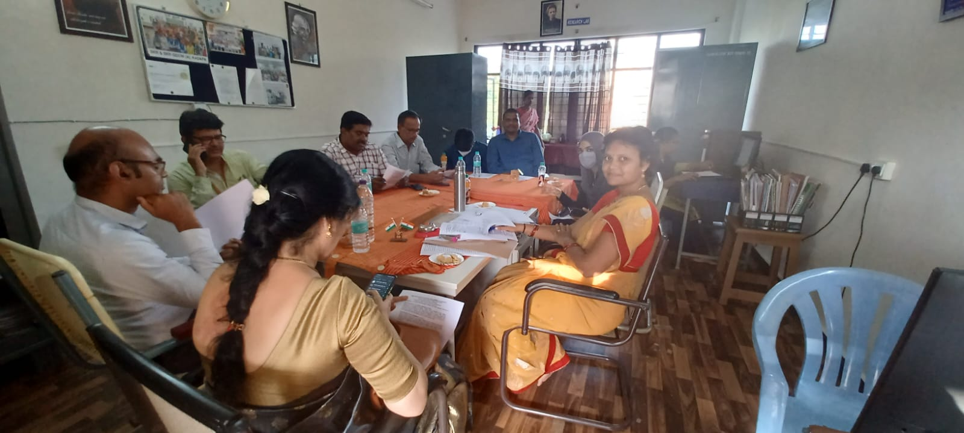  Dept of Physics on 29.08.2022 | 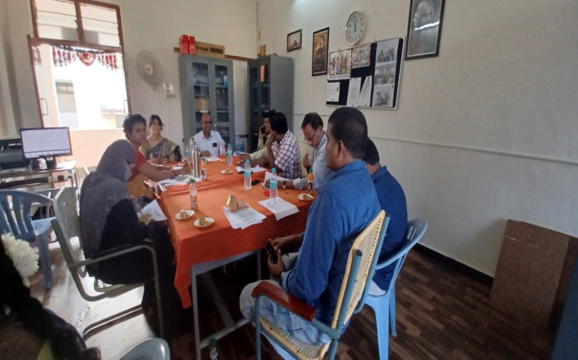  Dept of Physics on 29.08.2022
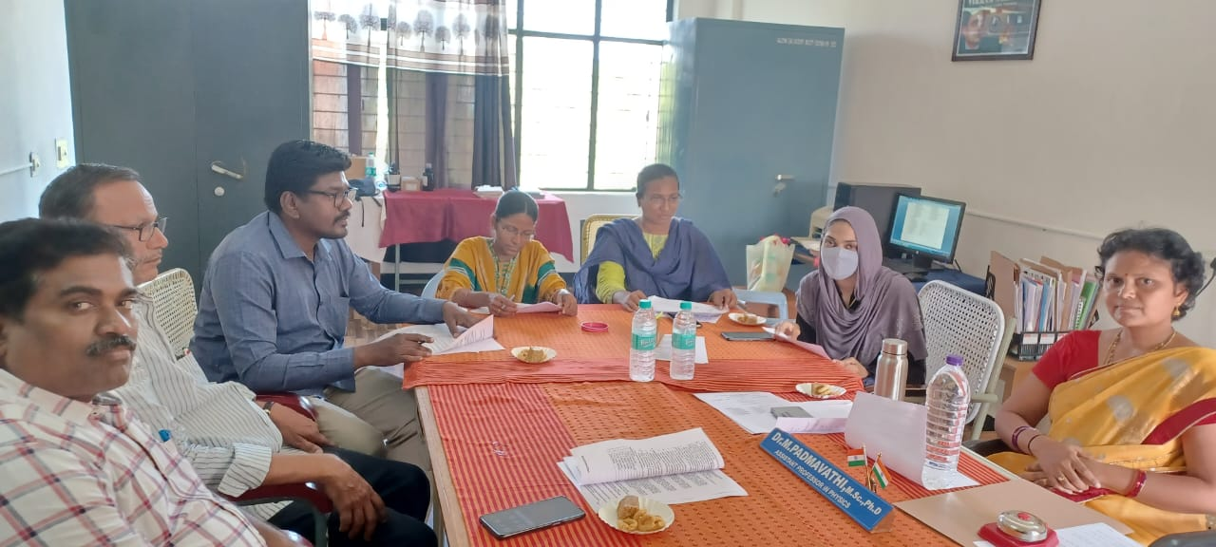Dept of Electronics on 29.08.2022 | 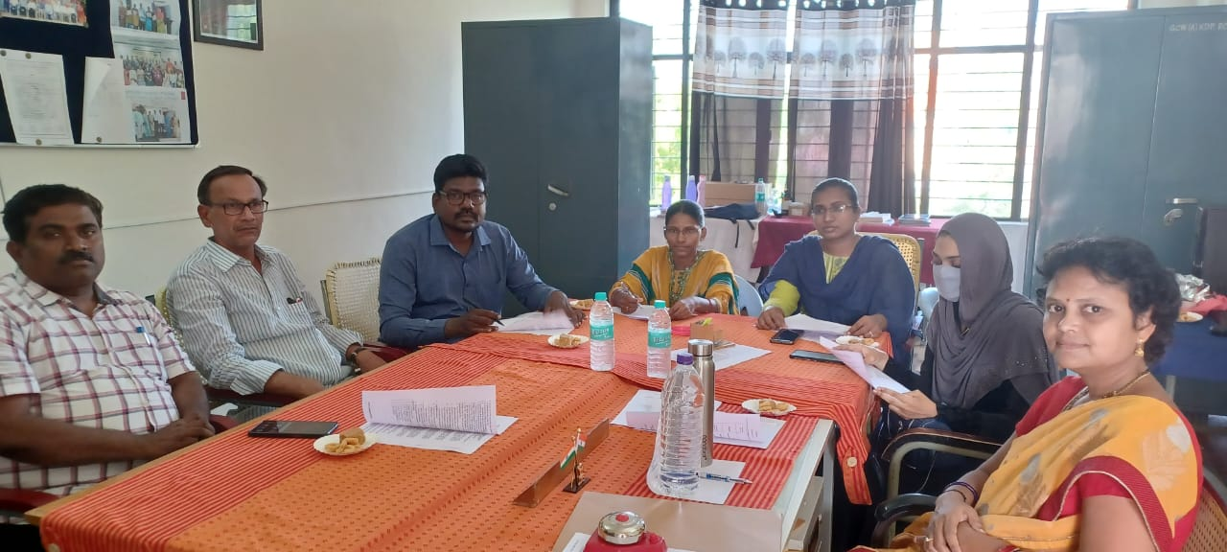  Dept of Electronics on 29.08.2022
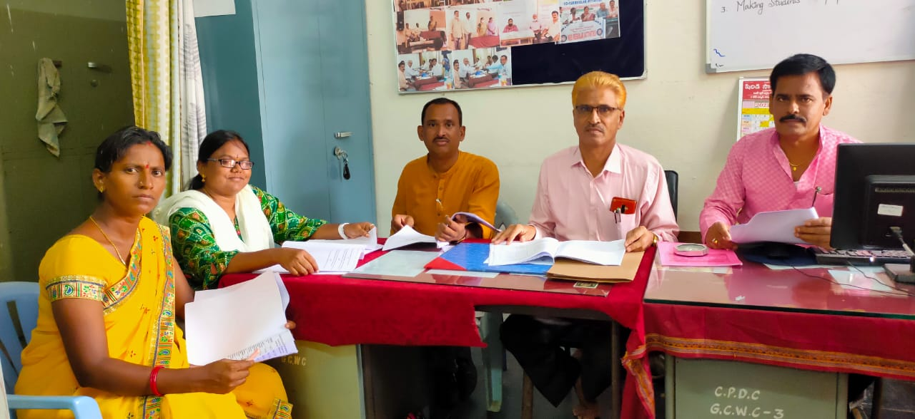  Dept of Political Science BoS on 29.08.2022 | 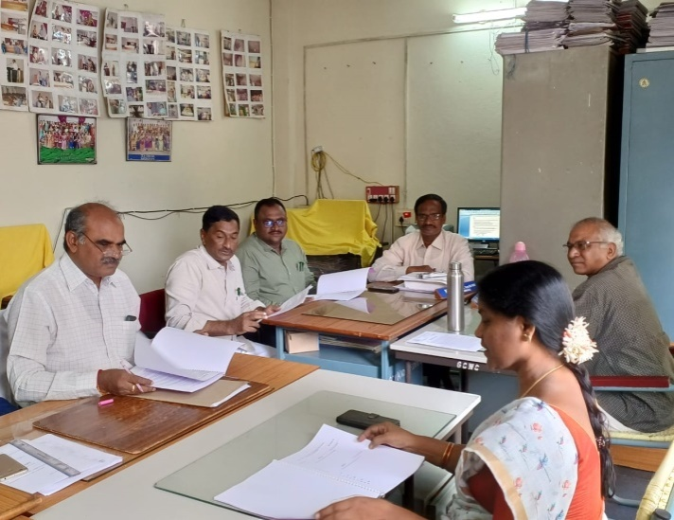  Dept of Commerce BoS on 29.08.2022
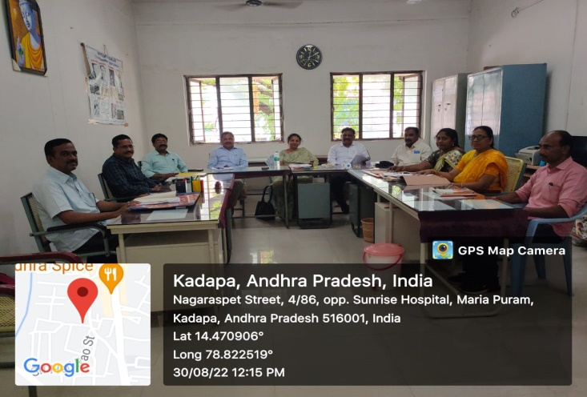  Dept of English BOS on 30.08.2022 | 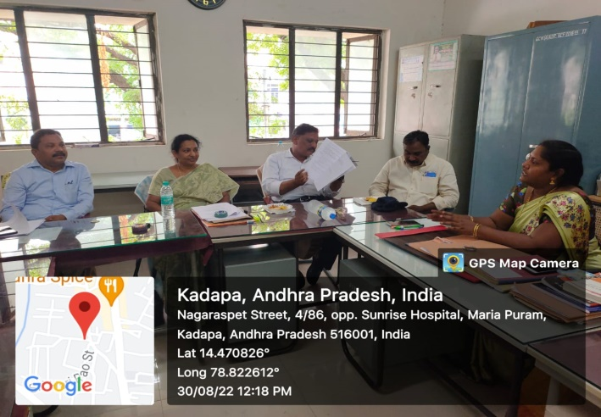  Dept of English BOS on 30.08.2022
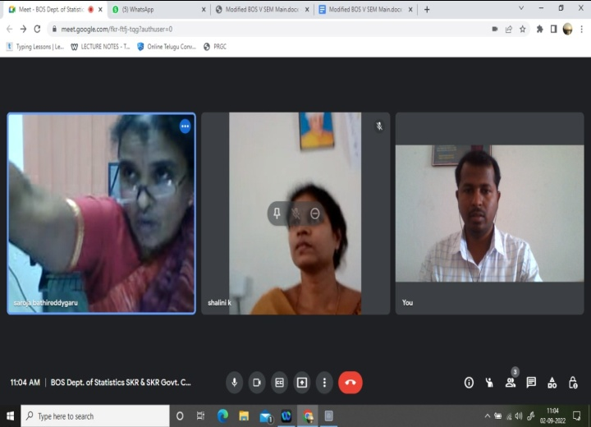  Dept of Statistics BoS on 02.09.2022 | 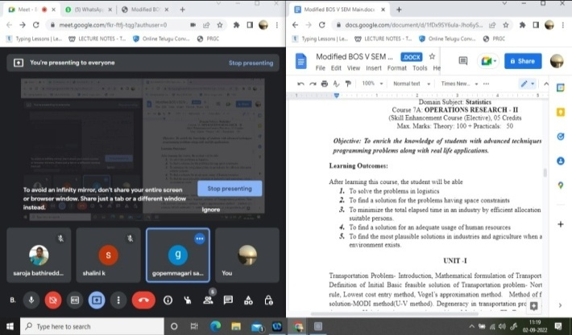  Dept of Statistics BoS on 02.09.2022
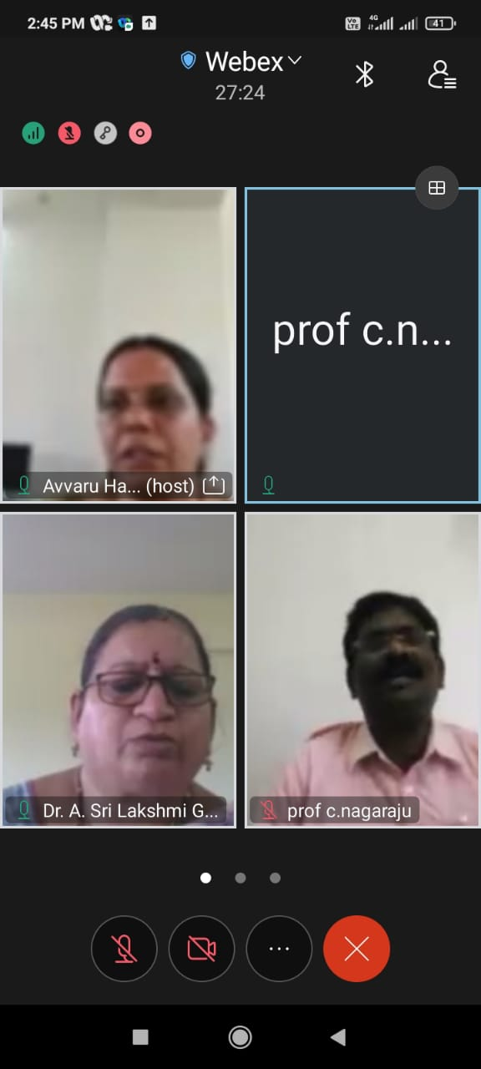  Dept of Computer Science BOS on 02.09.2022 | 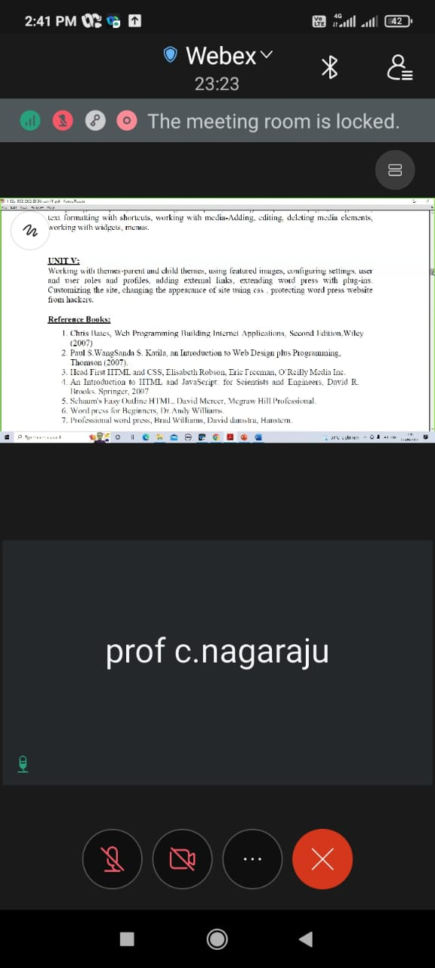  Dept of Computer Science BOS on 02.09.2022
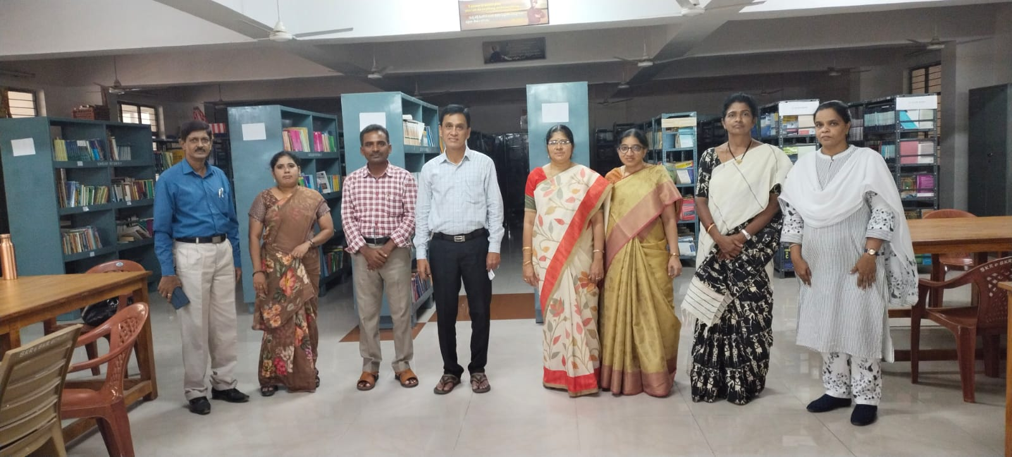  Dept of Zoology BoS on 03.09.2022 | 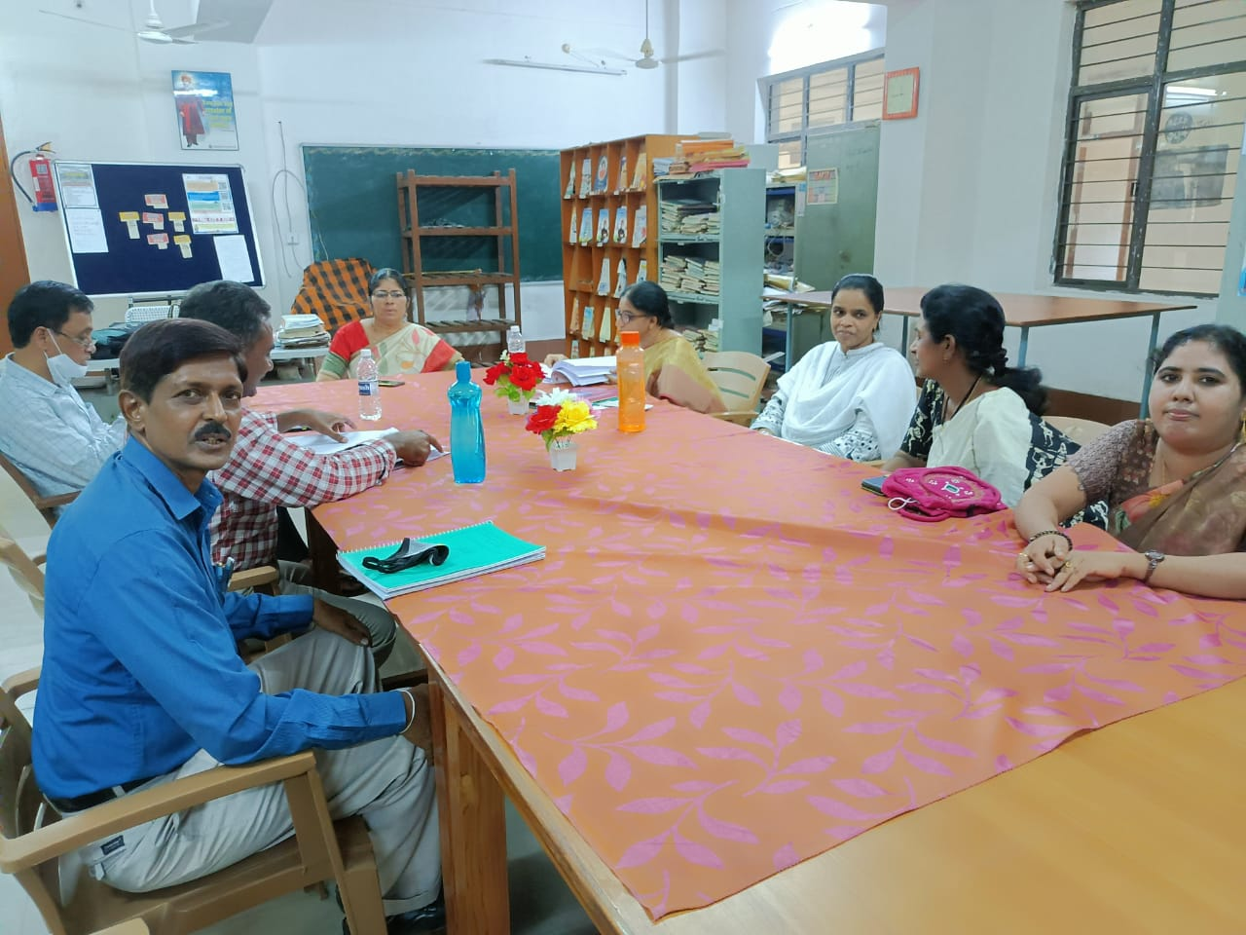  Dept of Zoology BoS on 03.09.2022
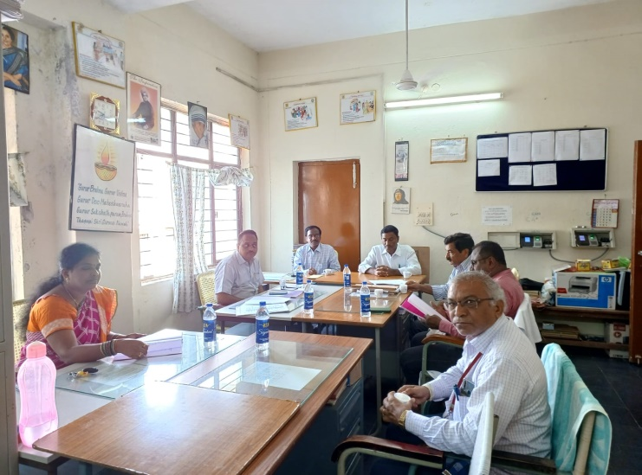  BBA- Event Management BoS on 07.09.2022 | 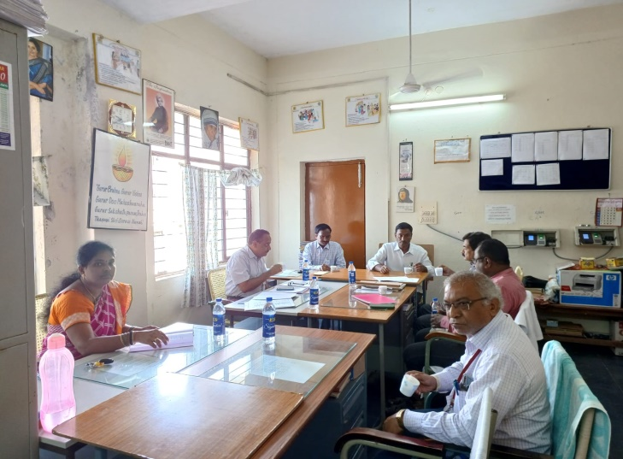  BBA- Event Management BoS on 07.09.2022
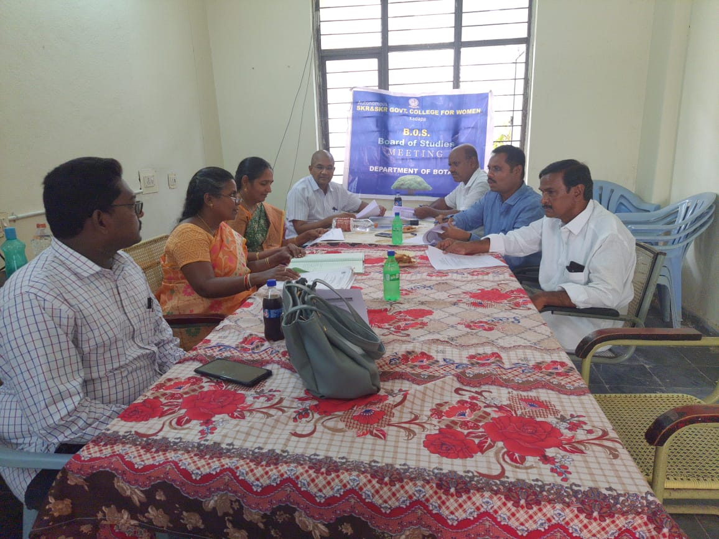  Dept of Zoology BoS on 07.09.2022 | 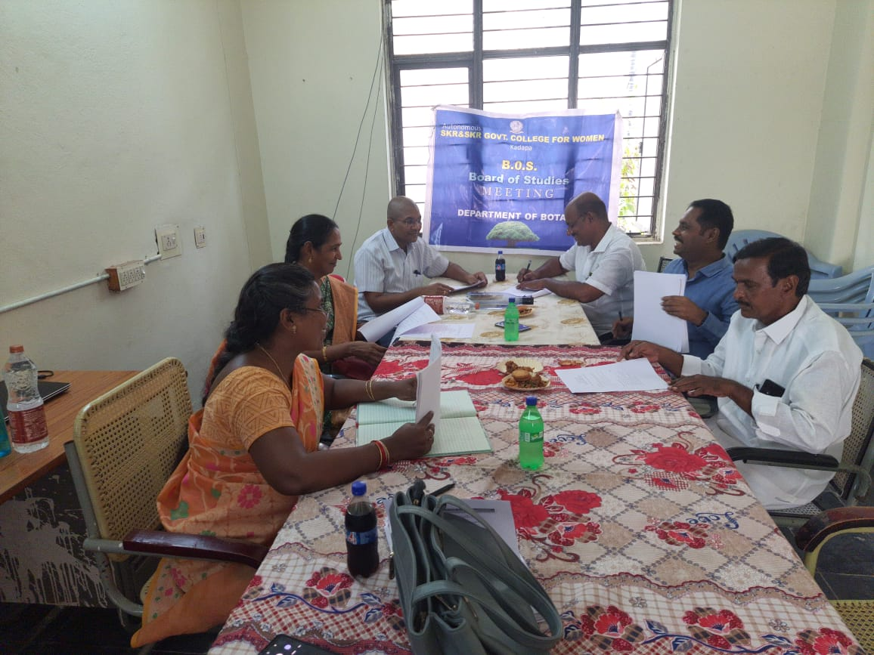  Dept of Zoology BoS on 07.09.2022

Video conference ON NAAC PREPAREDNESS
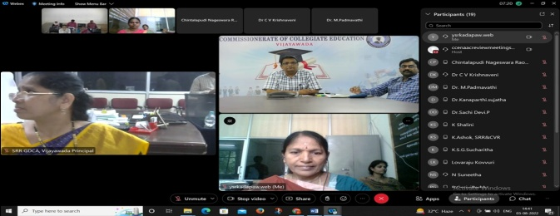 | 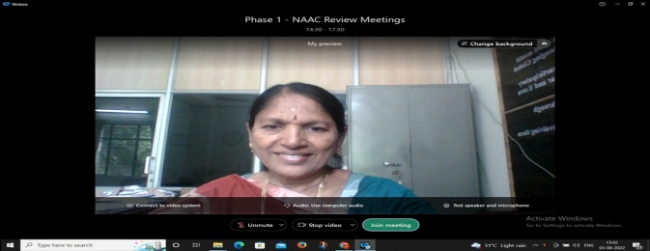
Dr Vijaya Babu garu, Academic guidance cell, Office of the Commissionerate of Collegiate Education conducted video conference with the Principals, NAAC Coordinators of NAAC going colleges on 03.08.2022. Dr P. Subba Lakshumma, Principal interacted with Vijay Babu garu and explained in detail about the status of NAAC preparedness, College profile, Submission of IIQA and SSR. Dr B. Swaroopa, NAAC Coordinator explained about the Vision and Mission of the college, SWOC Analysis, Recommendations of peer team members of previous NAAC and Criterion wise Convenors explained about the criterion inputs for SSR.
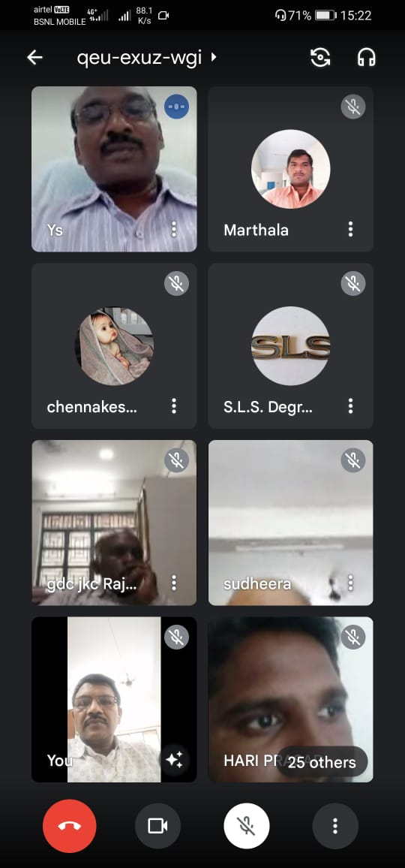 | Commissioner of Collegiate Education conducted video conference on 03.08.2022 on Internship registrations, selection of Industries, mapping of students with mentors and connect to the industries, about video lessons and completion of course, getting course completion certificate from the industry. Dr P. Subramanyam, Lecturer in Botany, LMS coordinator of the college attended the video conference.
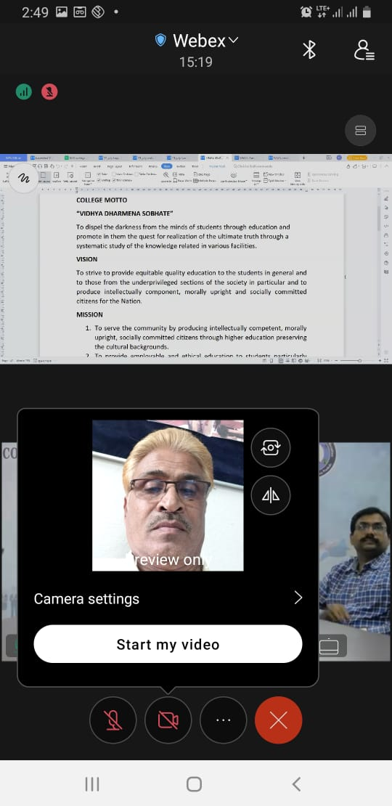 | Sri M. Veera bhadraiah, Lecturer in Political Science attended video conference on 03.08.2022 on the Fee structure of Autonomous UG colleges hosted by Commissioner of Collegiate Education.

ELOCUTION COMPETITION
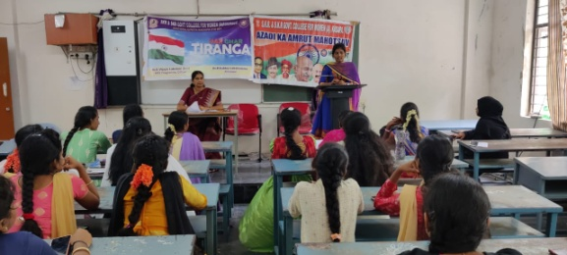 | 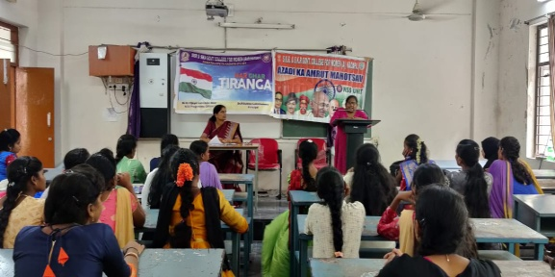
Dr G. Vijaya Lakshmi Devi, NSS Coordinator organised Elocution competition on the occassion of 75 years of Azadi ka Amrit Mahotsav on the topic entitled “Indian Freedom Fighters” on 05.08.2022. Final Year BA students actively participated in this competitions. Department of Economics faculty participated in this programme.
GUEST LECTURE
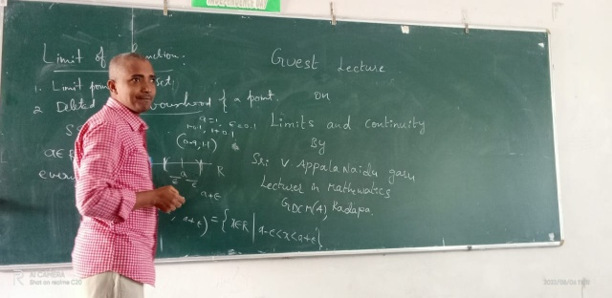 | 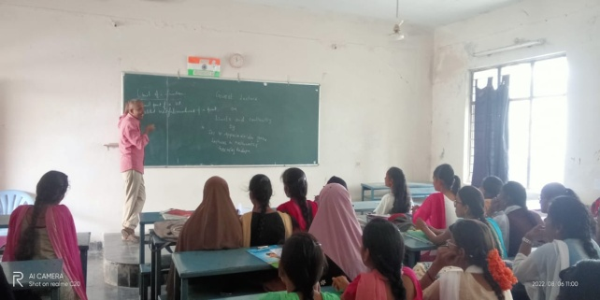
Department of Mathematics organised guest lecture on 06.08.2022. Sri V. Appalanaidu, Lecturer in Mathematics from Govt. College for Men (A), Kadapa acted as resource person and delivered guest lecture on the topic “ Limits and Continuity”. This lecture was very useful to the students and students clarified their doubts.
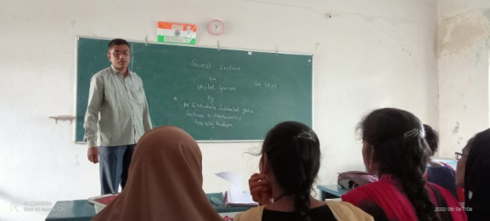 | 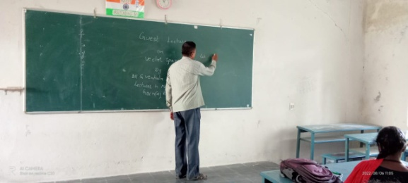
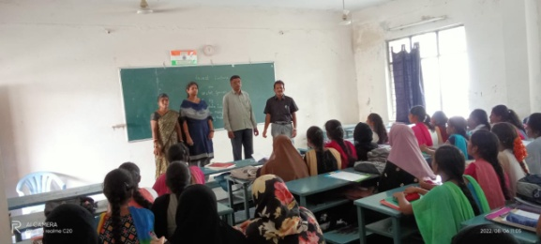 | Department of Mathematics organised guest lecture on 18.08.2022. Dr G. Venkata Subbaiah, Lecturer in Mathematics from Govt. College for Men (A), Kadapa acted as resource person and delivered guest lecture on the topic “ Differential Equations”. This lecture was very useful to the students and students clarified their doubts.

MLC VISIT to the college
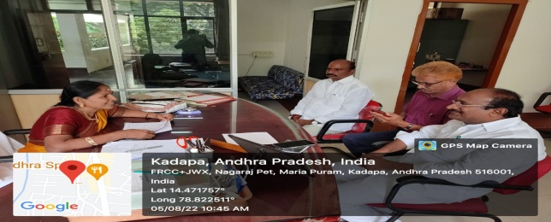 |  | 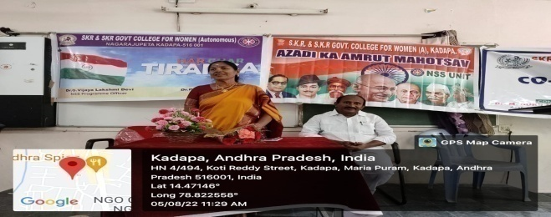
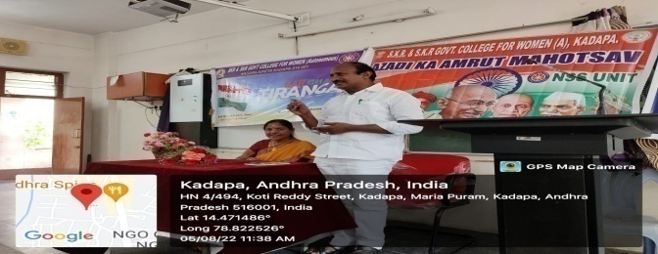 |  | 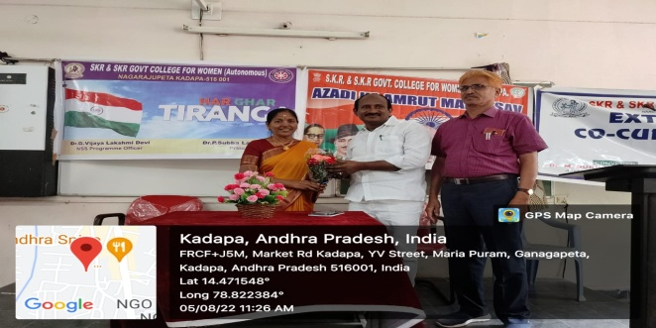
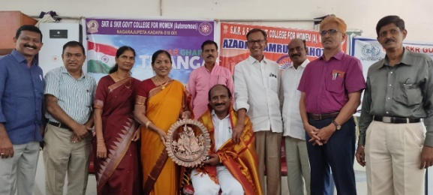 |  | 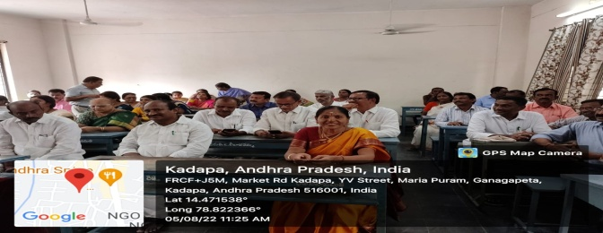
Hon'ble MLC Katti Narasimha Reddy garu visited the Institution on 05.08.2022 and delivered a talk on the occasion of Azadi Ka Amrut Mahotsav. He focussed on the reforms of education and encouraged staff to develop innovative methods of teaching. He interacted with teaching and non teaching staff.
College planning and development committee MEETING
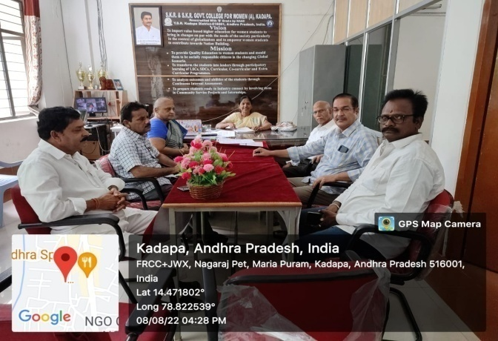 | College Planning and Development Committee of SKR & SKR Govt. College for Women (A), Kadapa met in the Principal chamber on 08.08.2022 and discussed and gave suggestions on various academic issues – Requirement of additional classrooms, Seminar Hall, Renovation of Auditorium, progress of NAAC preparedness. Smt L. Sudheera, Academic Coordinator, Dr P. Gurivi Reddy, Senior faculty participated.

NCC FAREWELL day celebrations
Dr M. Padmavathi, NCC Coordinator organised farewell day function to all the NCC cadets on 08.08.2022. Dr P. Subba Lakshumma, Principal inaugurated the function and explained in detail about the importance of NCC and roles and responsibilities of NCC cadets improve their overall personality by teaching them leadership qualities, discipline, honesty working in a team, time management to have high self-confidence, being physically fit, service before self, social service, and responsibility of service towards motherland. Principal issed B certificates to the students.
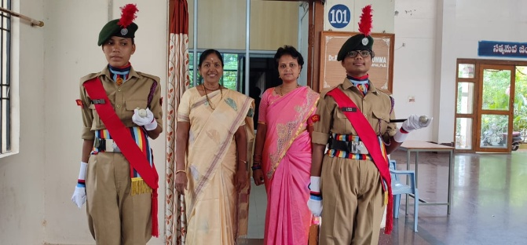 | 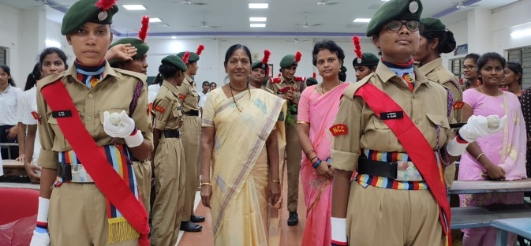
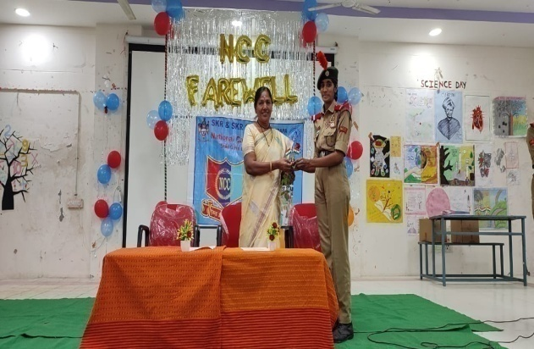 | 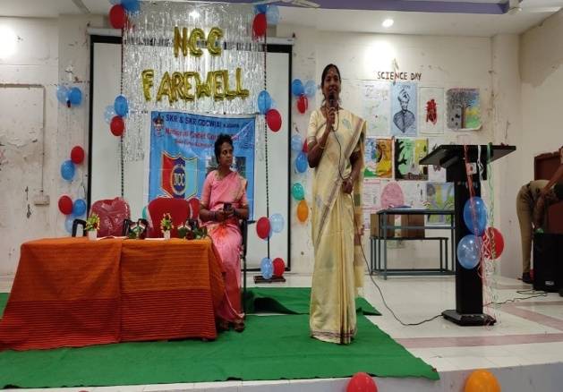
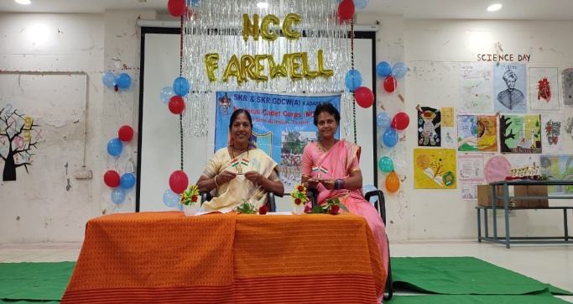 | 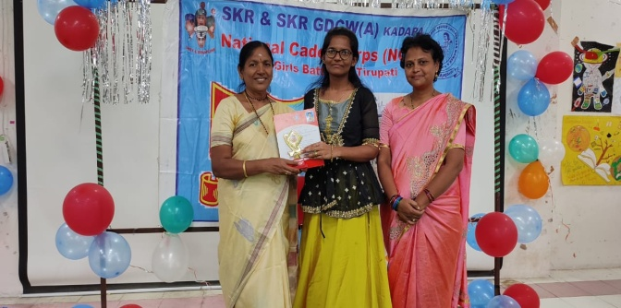
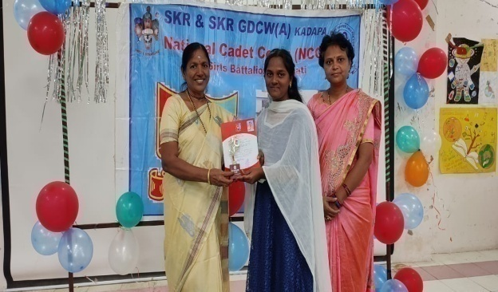 | 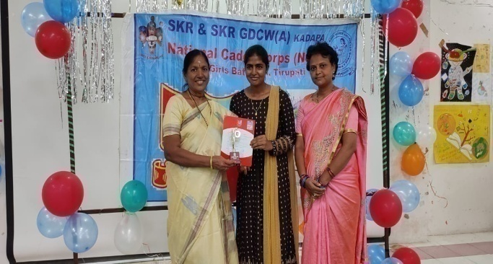
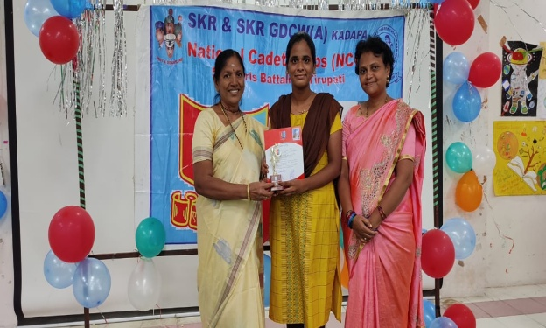 | 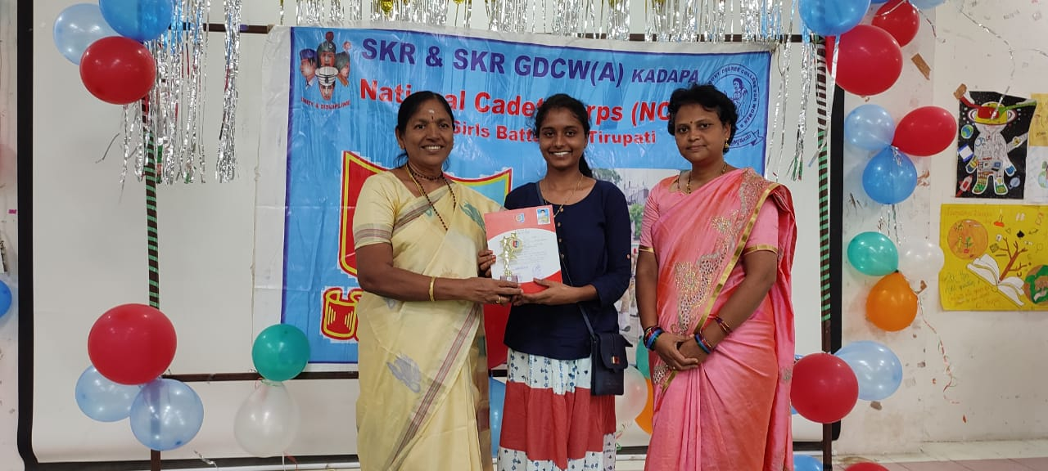
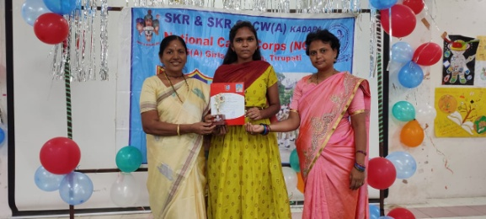 | 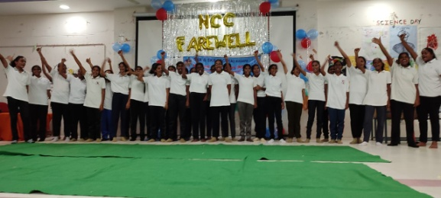
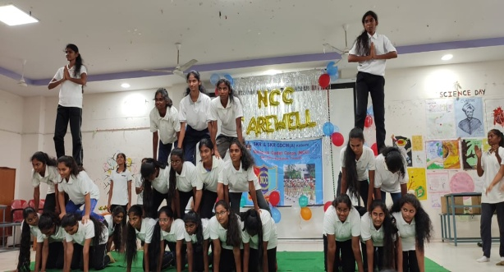 | 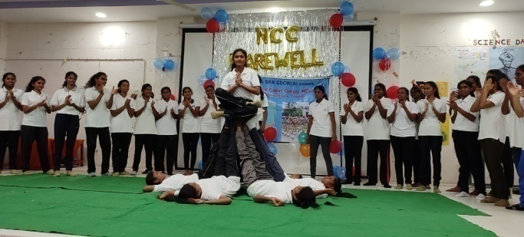
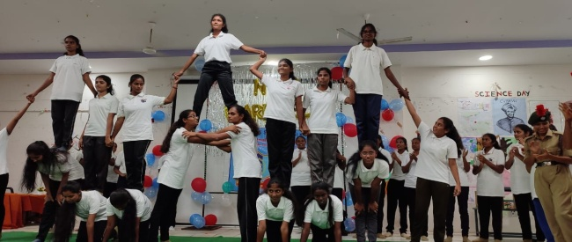 | 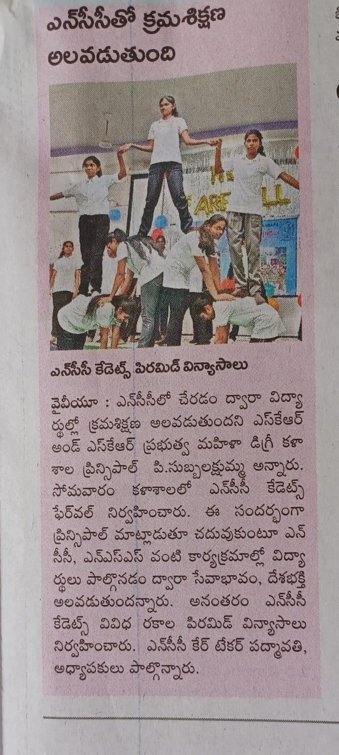

TREE PLANTATION PROGRAMME
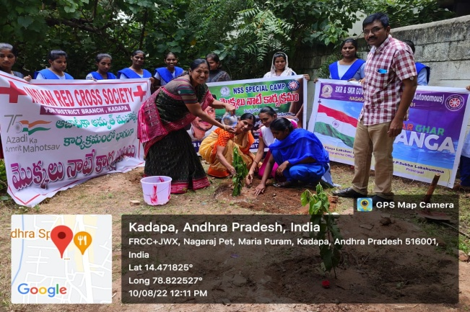 | 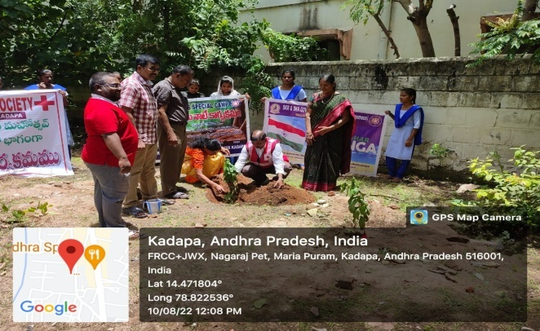
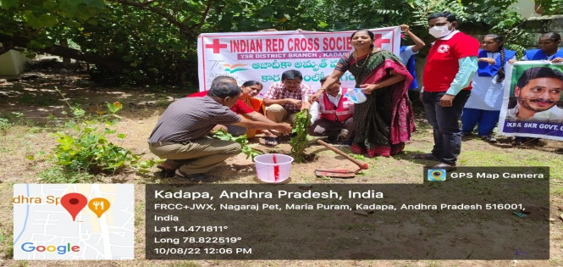 | 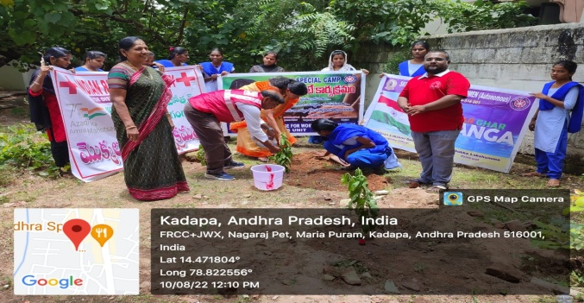
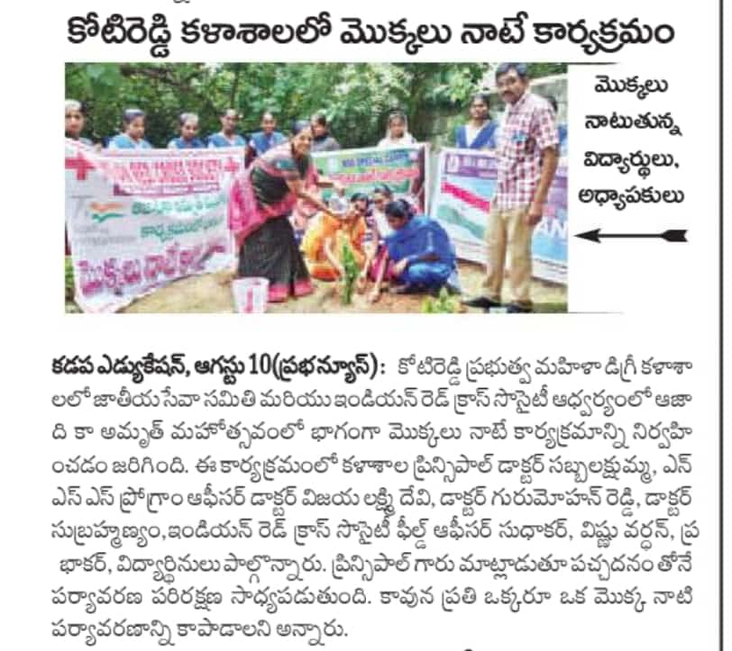 | 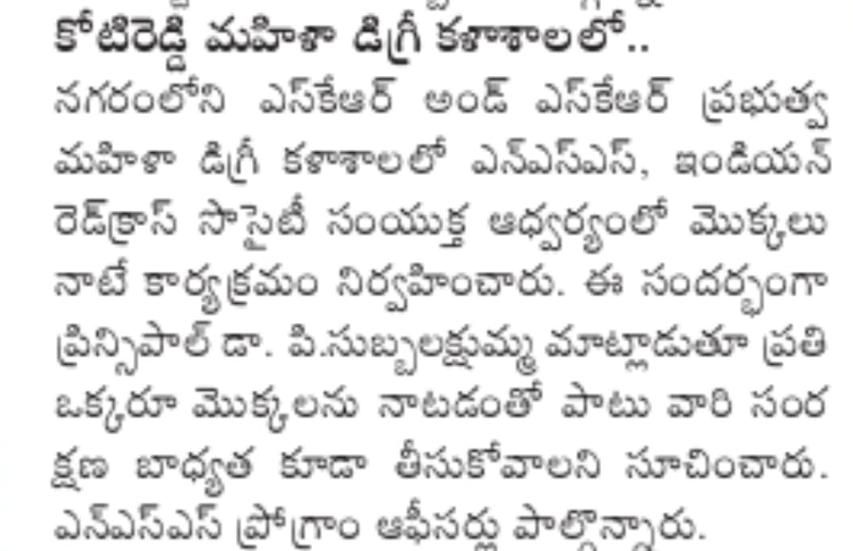
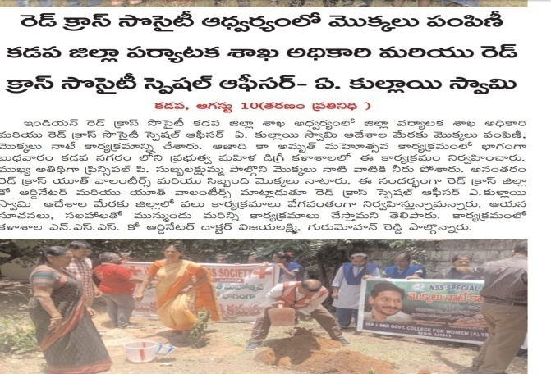 | 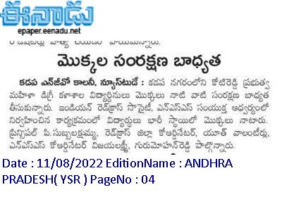
On the occassion of Azadi Ka Amrut Mohotsav NSS Unit conducted Tree plantation programme with the collaboration of NGOs - Meekosam Educational & Rural Development society & Indian Red Cross Society on 10.08.2022. Dr P. Subba Lakshumma, Principal planted sapling in the college premises. Dr G. Vijaya Lakshime Devi, NSS Coordinator, Dr P. Subramanyam, Lecturer in Botany and students participated in this programme.

5 DAY RESIDENTIAL TOT PROGRAMME ON CONTENT DELIVERY
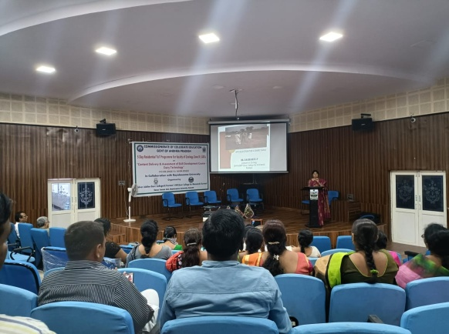 | Dr P. Sachi Devi, Lecturer in Zoology participated 5 day Residential ToT Programme on Content Delivery at Silver Jubilee Govt. College (A), Kurnool and gave presentation on the topic site selection for a diary farm from 10.08.2022 to 14.08.2022.
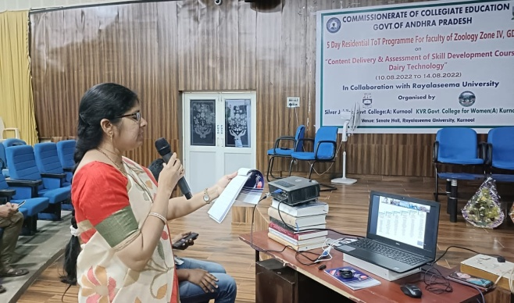  Dr P. Sachi Devi gave feedback on the FDP. | 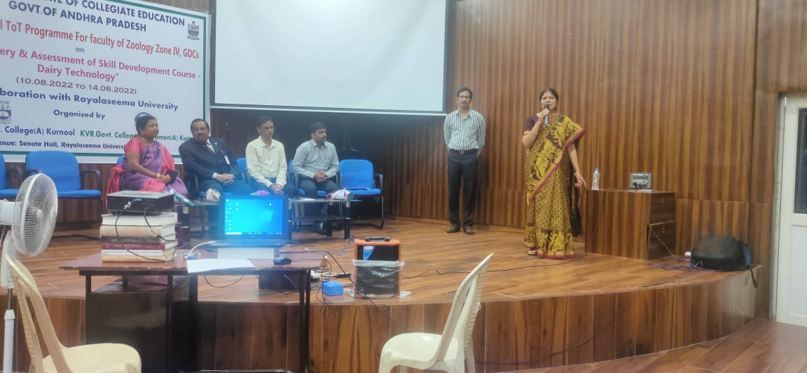
Smt D. Winni Teja, Lecturer in Chemistry attended one day programme on content generation of non core subjects at Govt. College for Women(A), Guntur on 11.08.2022. Dr Pola Bhaskar garu, Commissioner of Collegiate Education address the gathering. | 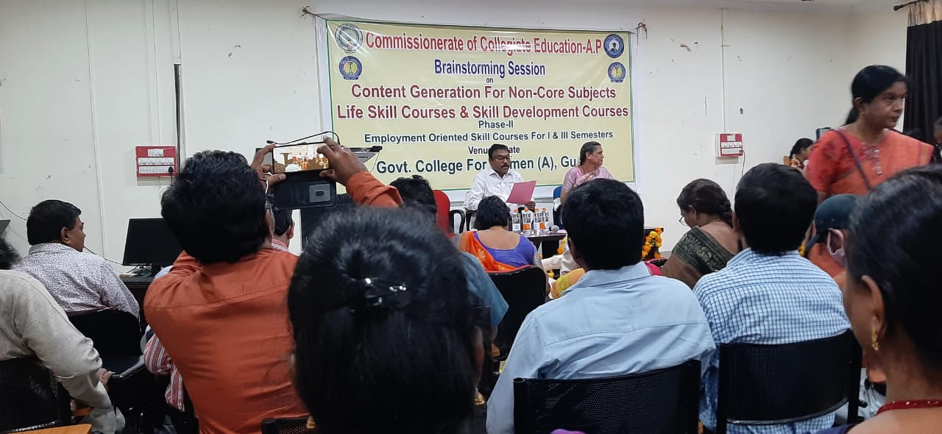
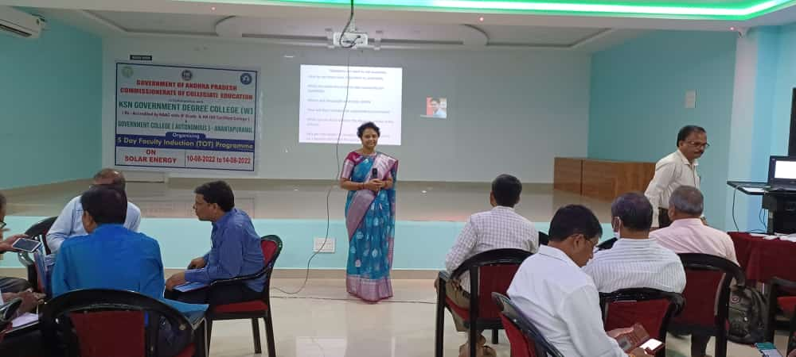 | 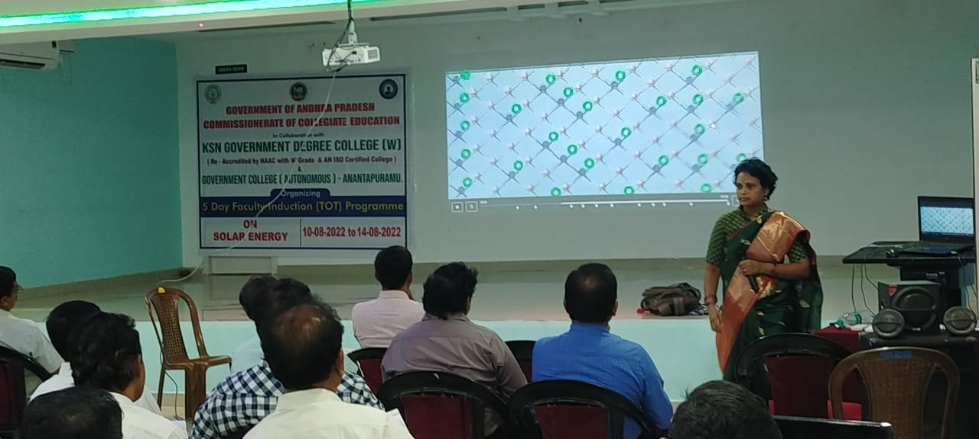
Dr M. Padmavathi, Lecturer in Zoology attended 5 days ToT programme on content generation of Solar Energy at KSN Govt. Degree College (W), Ananthapuram from 10.08.2022 to 14.08.2022.

AZADI KA AMRIT MAHOtSAV RALLY
On the occassion of Azadi Ka Amrit Mahotsav Dr P. Subba Lakshumma, Principal, staff and students conducted rally on 12.08.2022 and made poster presentations of Indian Freedom Fighters.
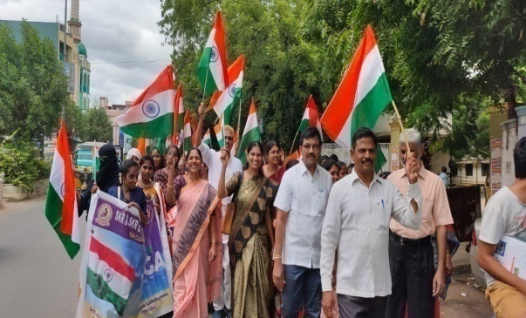 | 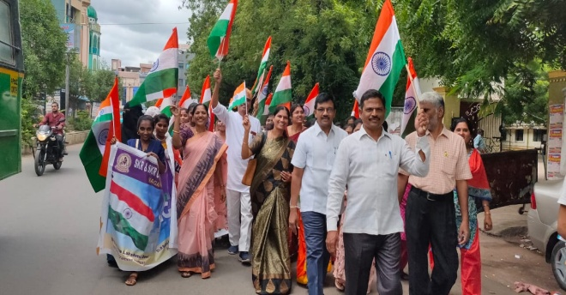
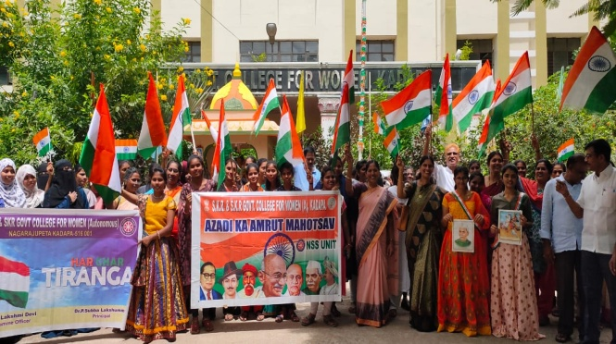 | 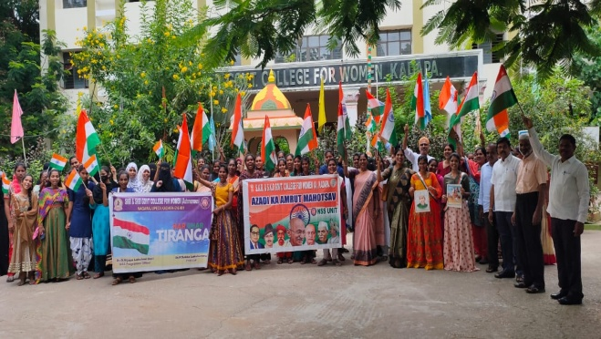
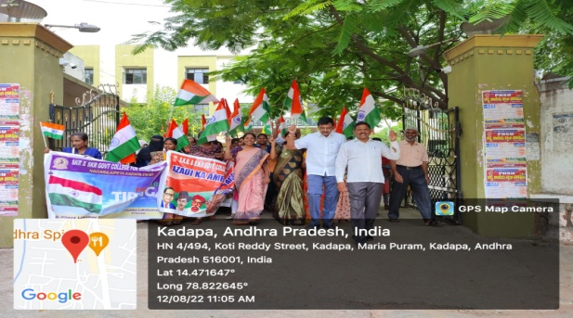 | 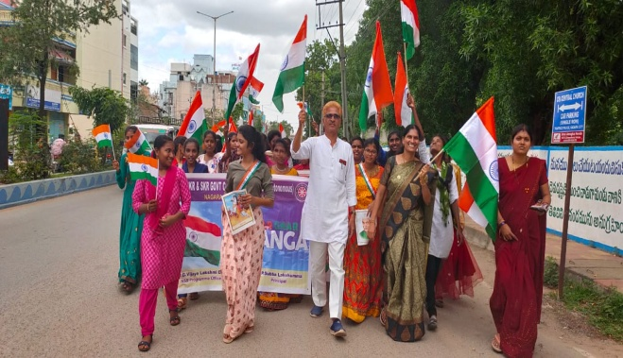
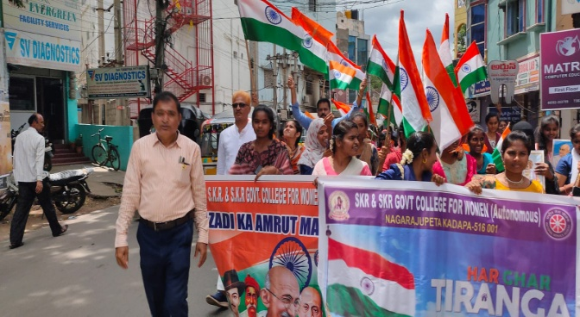 | 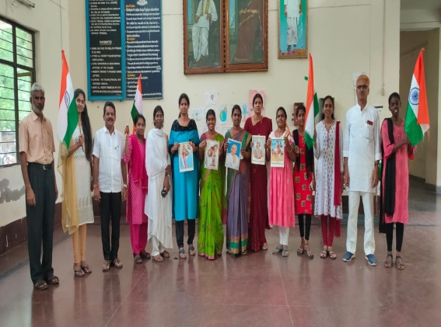

AZADI KA AMRIT MAHOTSAV FLAG HOISTING BY PRINCIPAL
On the Occassion of 75 years of Independence Day celebrations Dr P. Subba Lakshumma, Principal hoisted flag and explained in detail about the struggle faced by Indian Freedom Fighters in achieving the Independence. Sri R. Sreenivasula Reddy, President of Sir C.V Raman Science Club, Kadapa division exhibited the posters of National freedom Movement and Freedom Fighters on 13.08.2022. All the teaching,non-teaching staff and students participated in this programme.
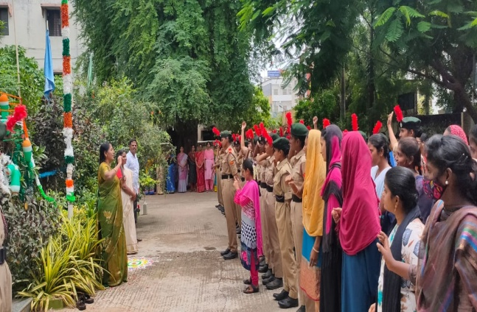 |  | 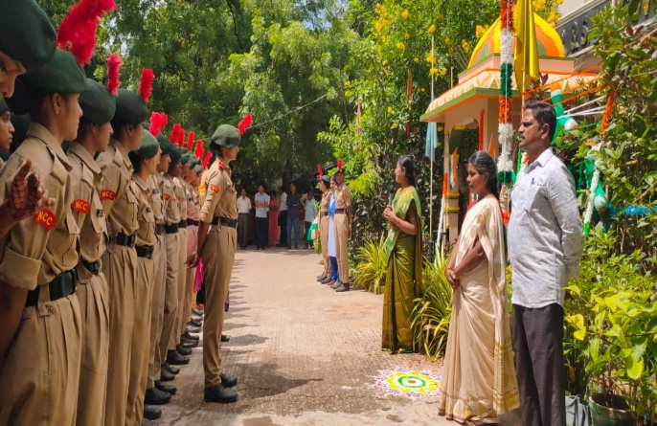
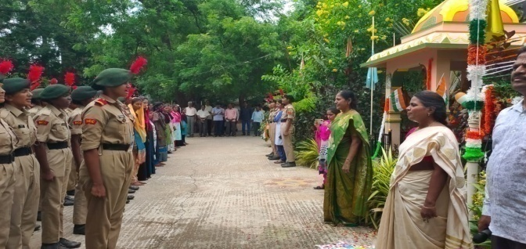 |  | 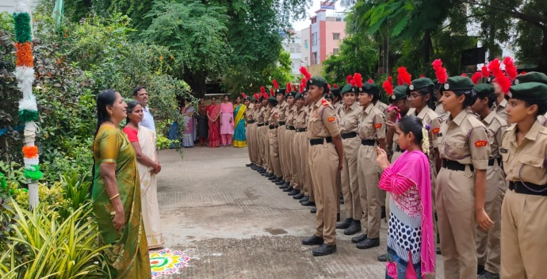
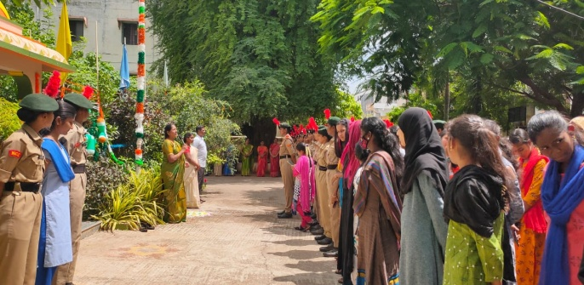 |  | 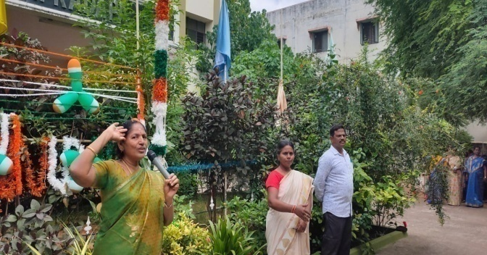
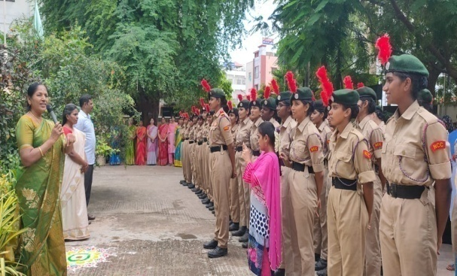 |  | 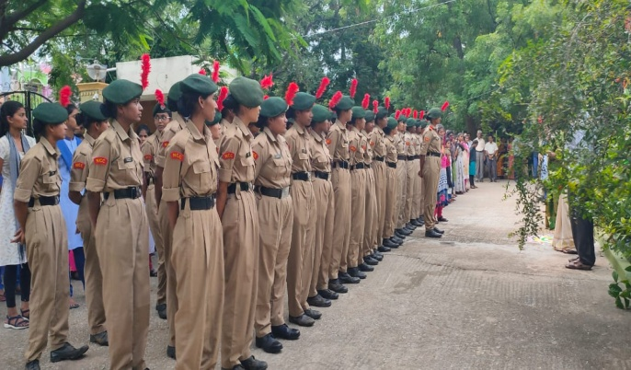
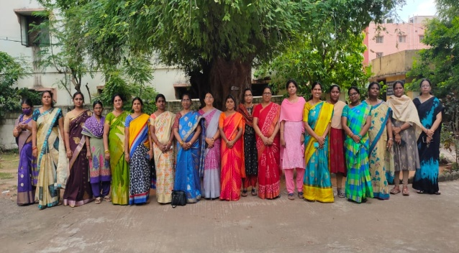 |  | 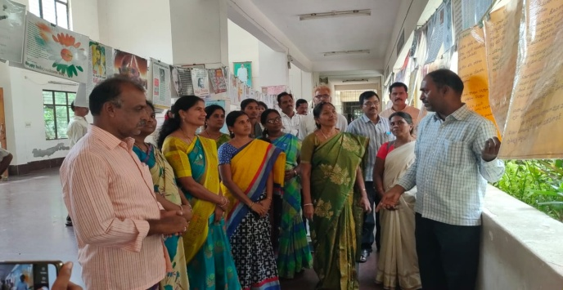
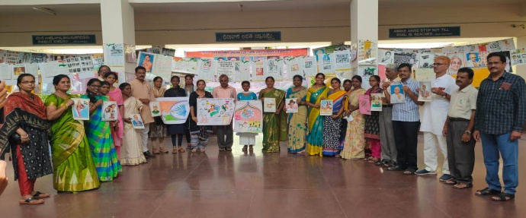 |  | 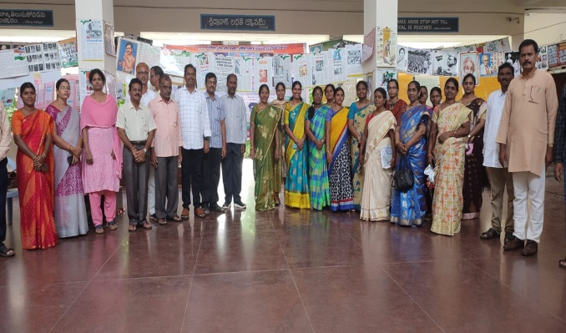
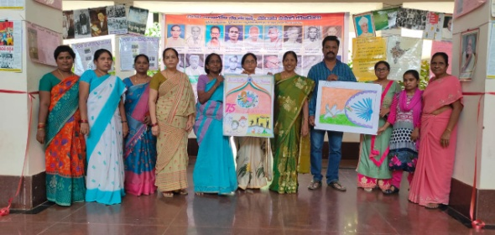 |  | 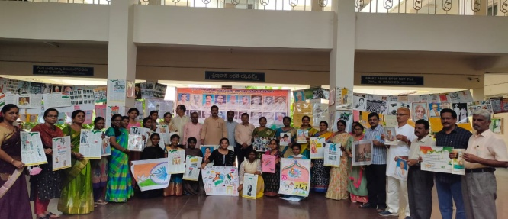
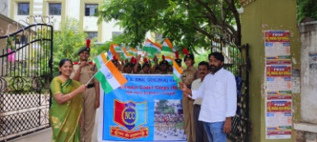 |  | 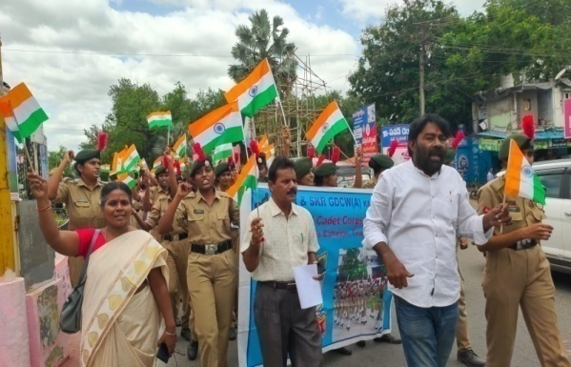
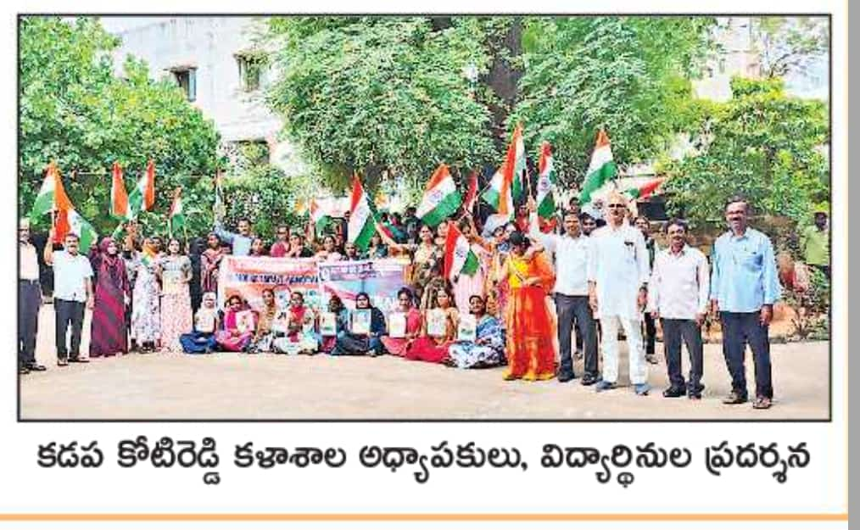 |  | 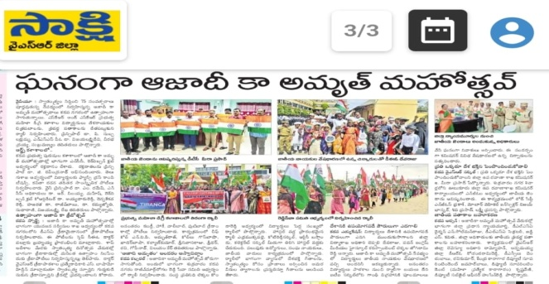
PARTITION HORRORS REMEMBRANCE DAY 14.08.2022
On the occasion of Azadi Ka Amrit Mahotsav an awareness programmes was conducted on Partition Horrors Remembrance Day on 14.08.2022 organised by Women Empowerment Cell, Extra Curricular & Cocurricular Activity Committee. Dr P. Subba Lakshumma, Principal inaugurated the meeting and explained in detail about the commemorates the victims and sufferings of people during the partition of India. Bloody partition in which a million people were killed, and many were displaced from their homes. August 14 not only marks 75 years since the parititon of a great country India into 3 parts, but now is also observed as parition Horrors Remembrance Day. On this occassion Principal, Staff and District youth committee members felicitted Dr N. Anand Kumar Reddy garu – son of Kadapa district free fighter Sri N. Gangi Reddy garu.
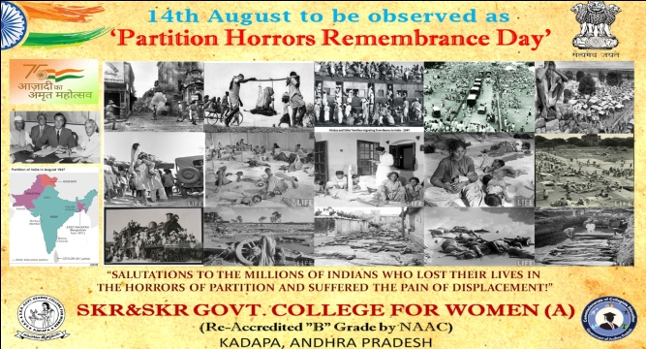 | 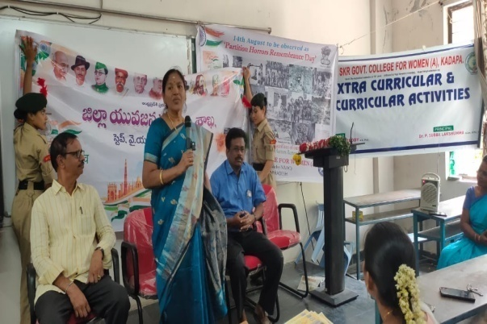
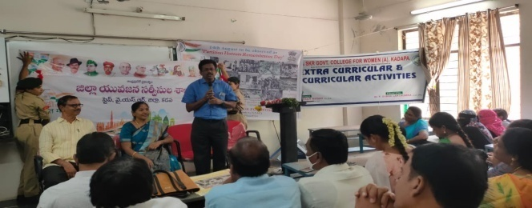 | 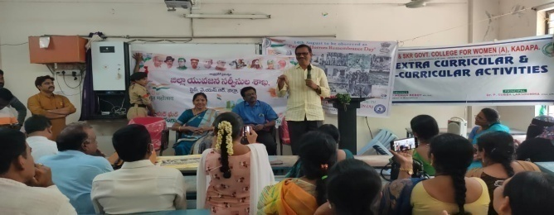
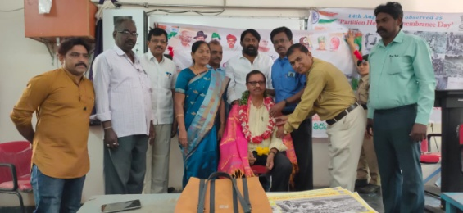 | 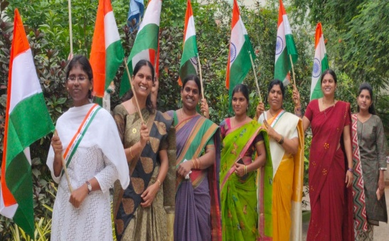
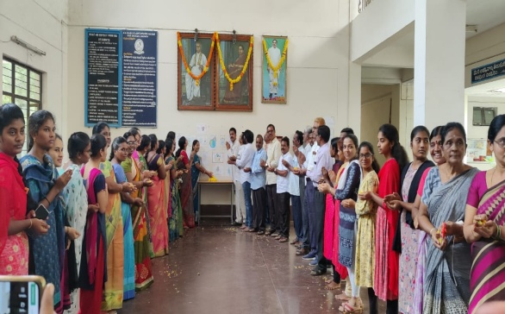 | 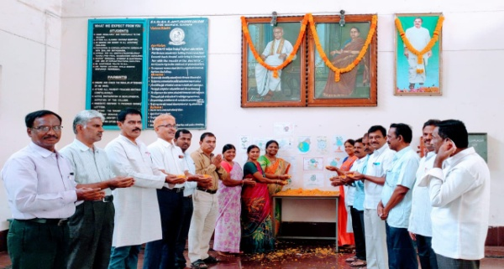
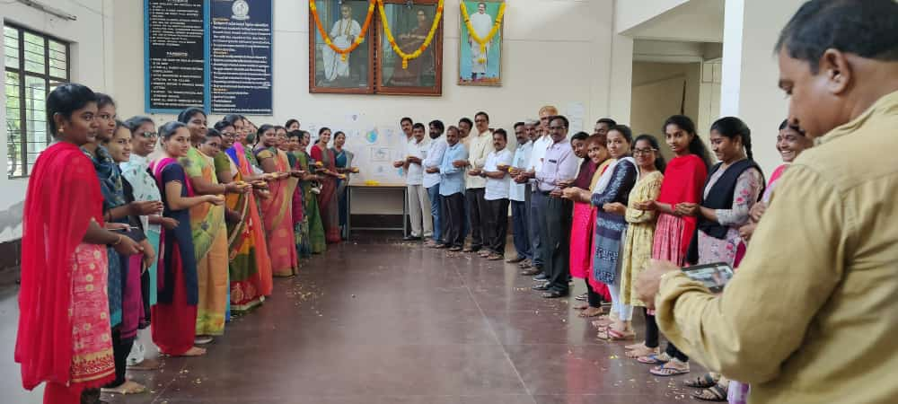 | 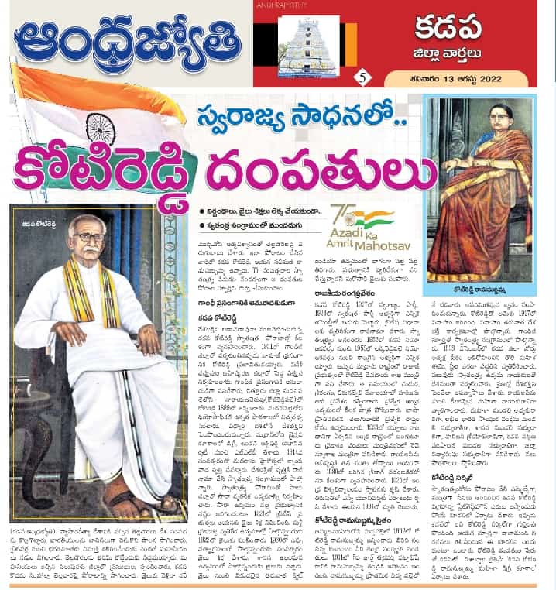
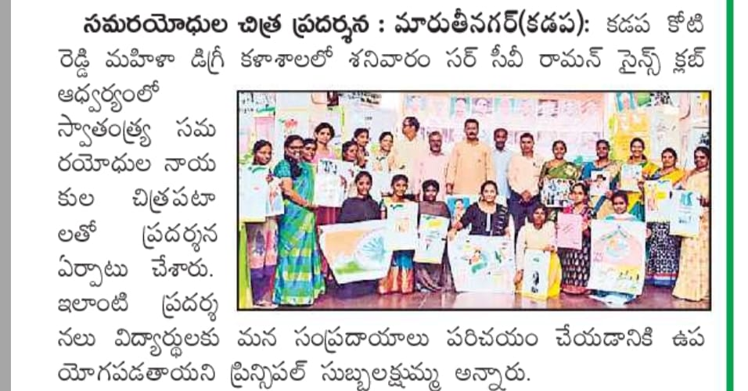 | 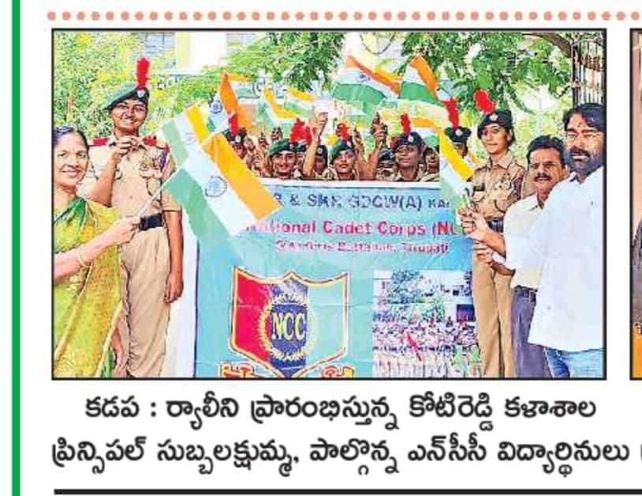
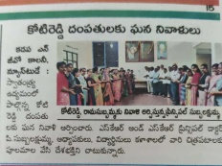 | 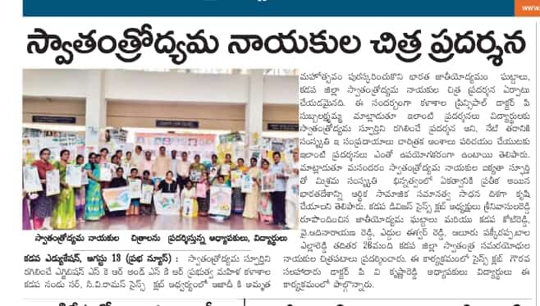
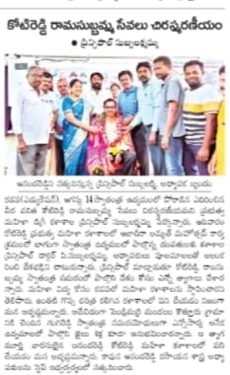 | 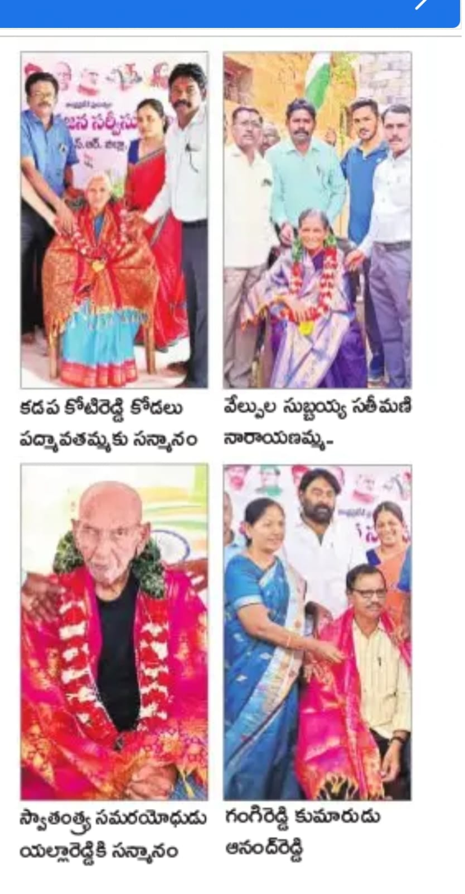

INDEPENDENCE DAY CELEBRATIONS
On the occassion of 75 years of Independence Day celebrations Dr P. Subba Lakshumma, Principal hoisted National Tricoloured Flag on 15.08.2022. All the staff and students saluted with great respect and patriotism. Principal inspired the students by explaining the significance of Tricoloured flag. NCC Cadets presented Guest of honour. Principal distributed prizes to the winners.
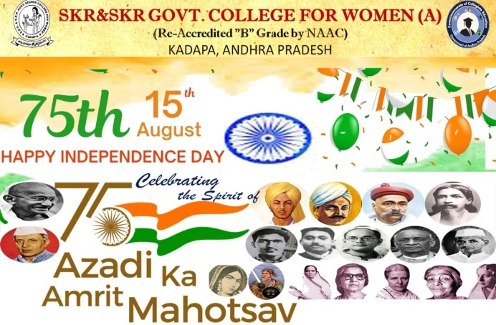 | 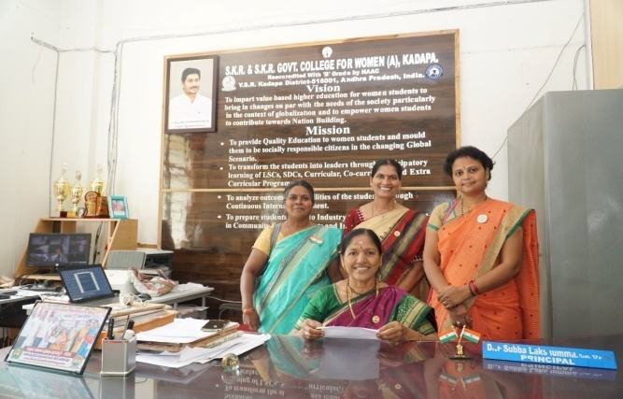
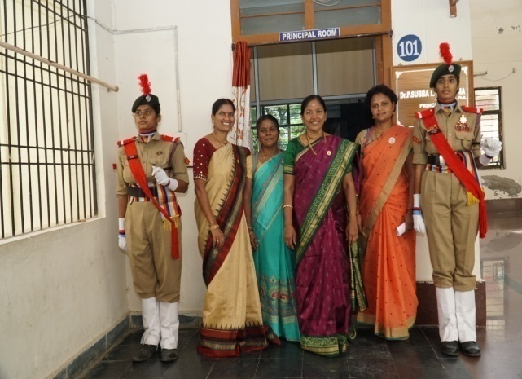 | 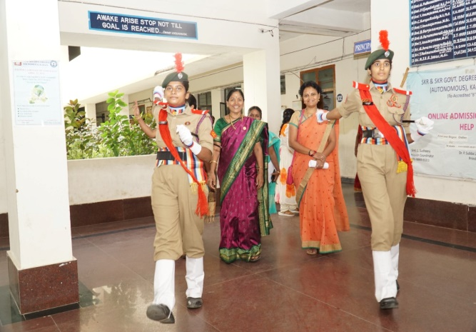
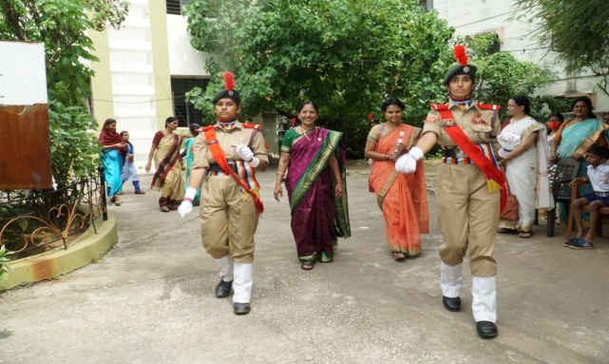 | 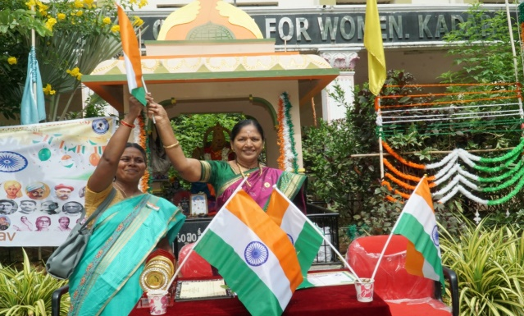
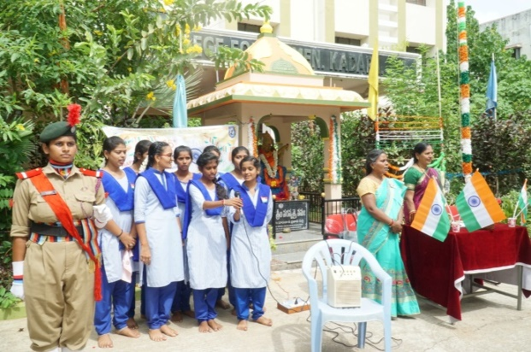 | 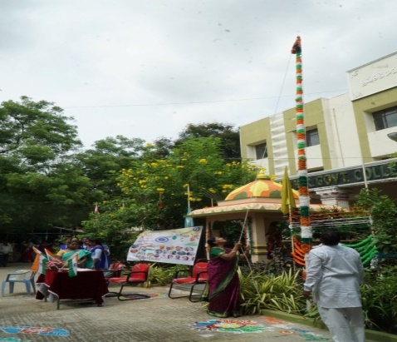
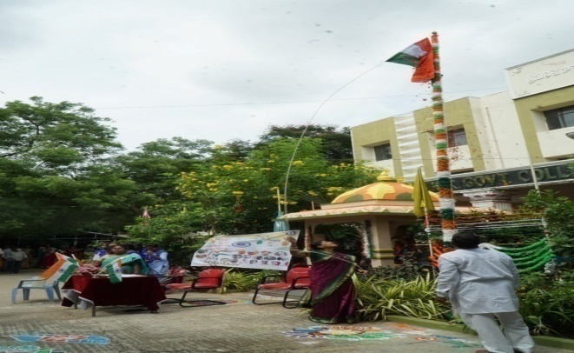 | 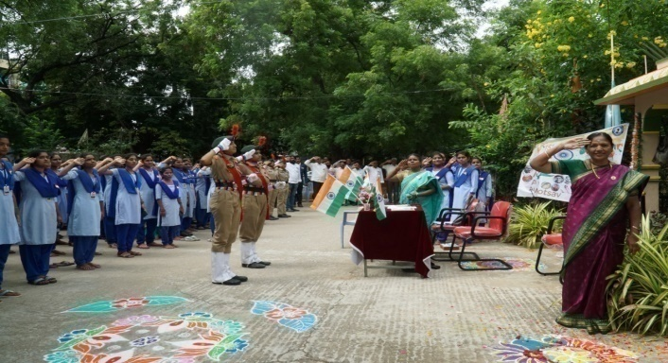
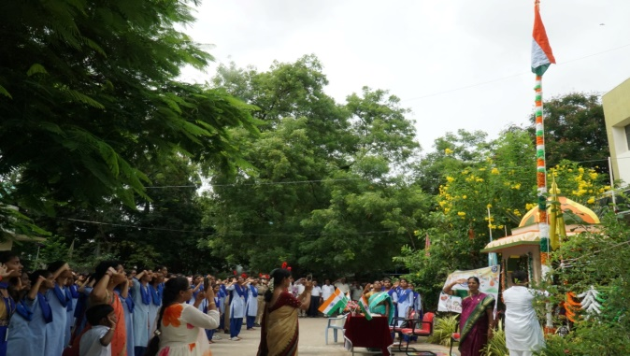 | 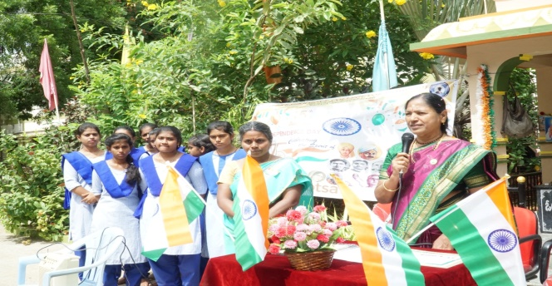
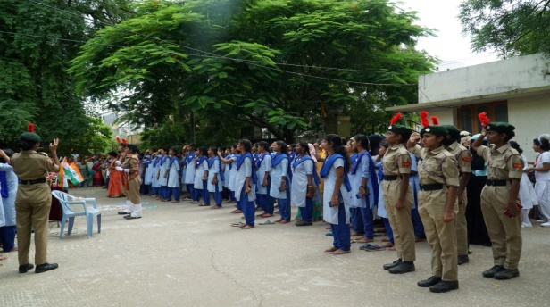 | 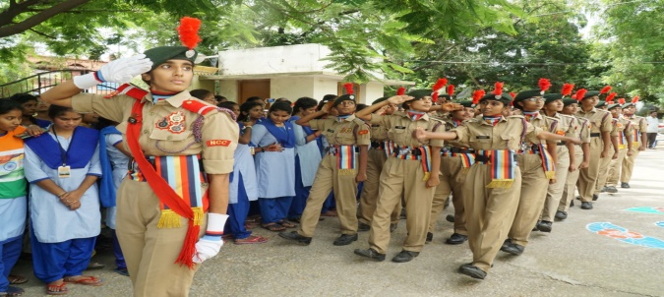
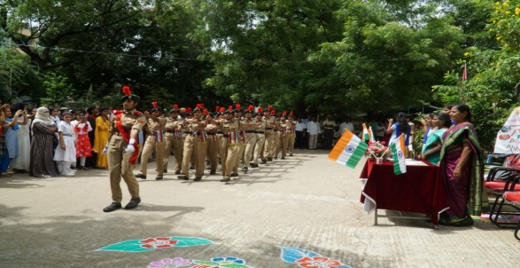 | 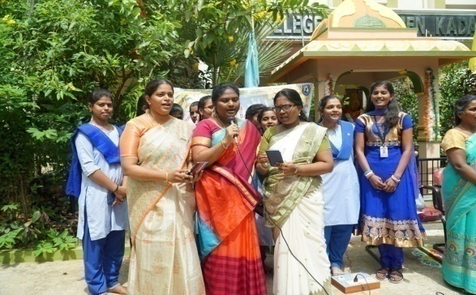
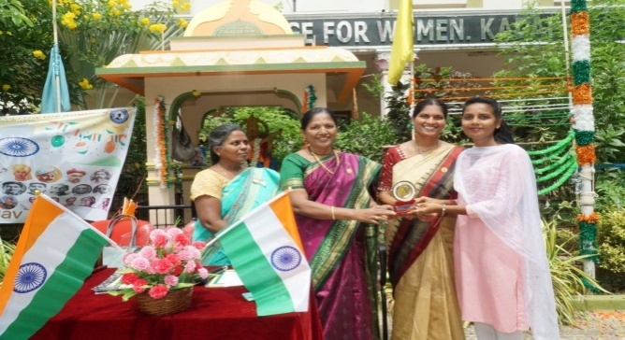 | 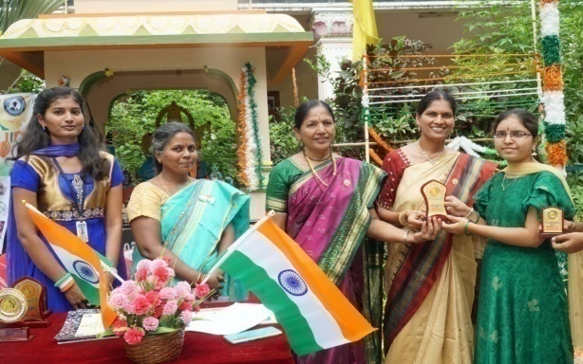
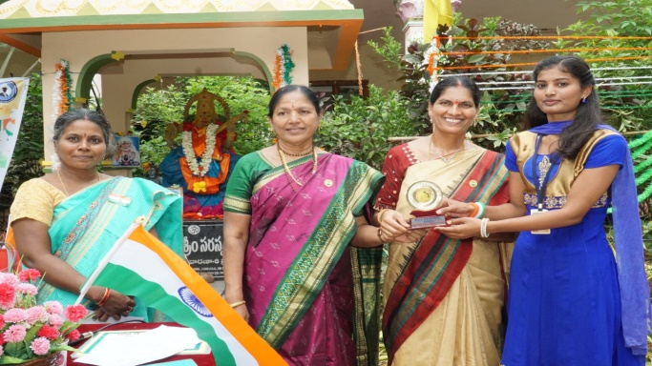 | 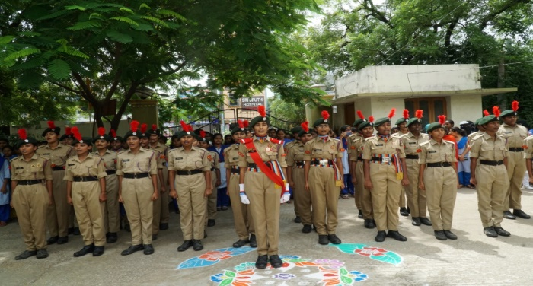
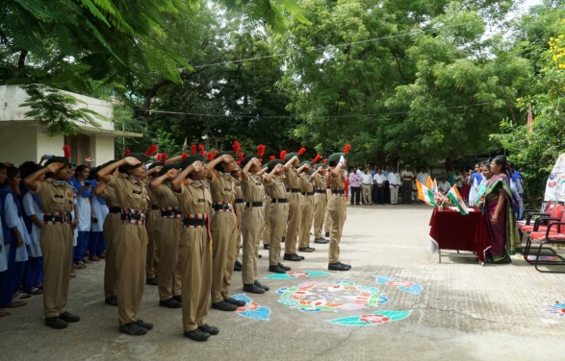 | 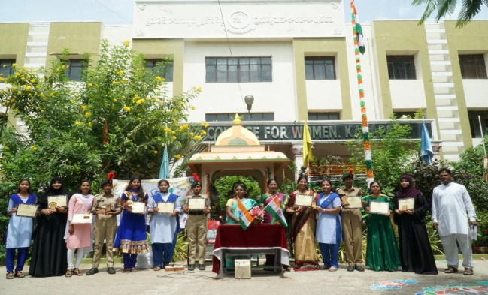
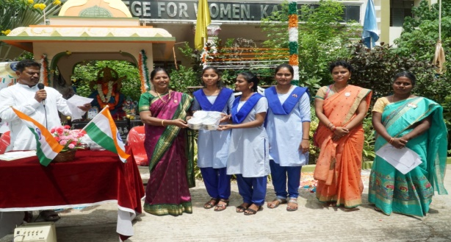 | 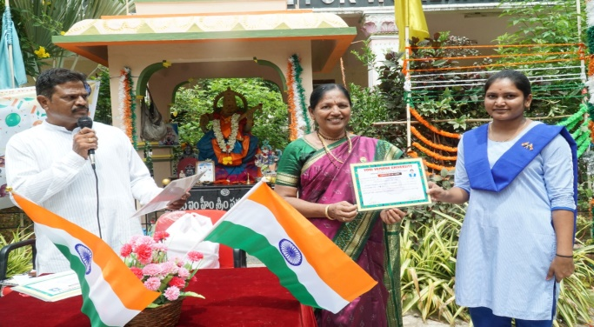
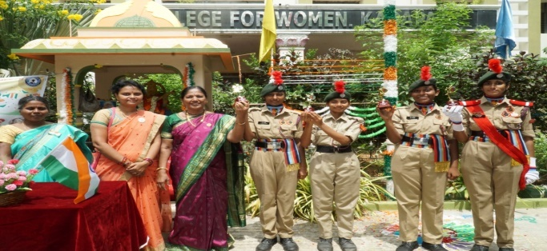 | 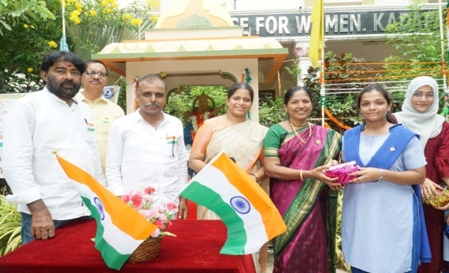
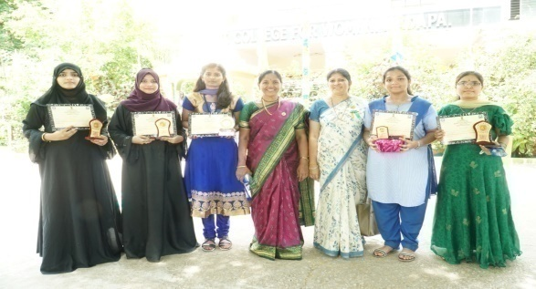 | 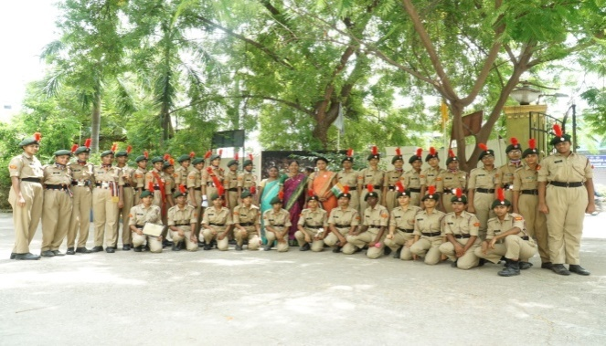
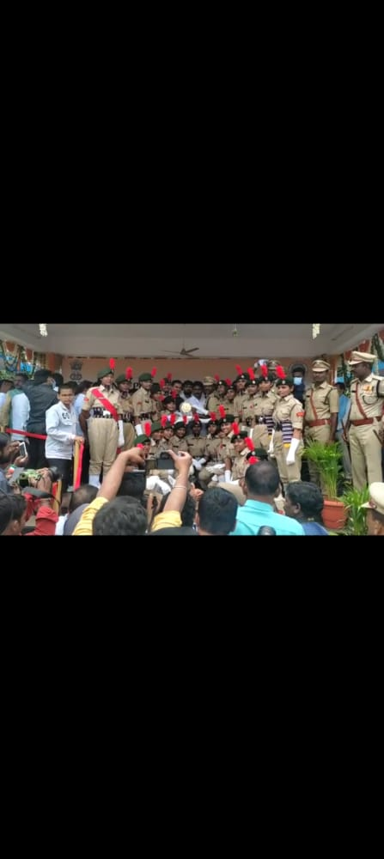 | 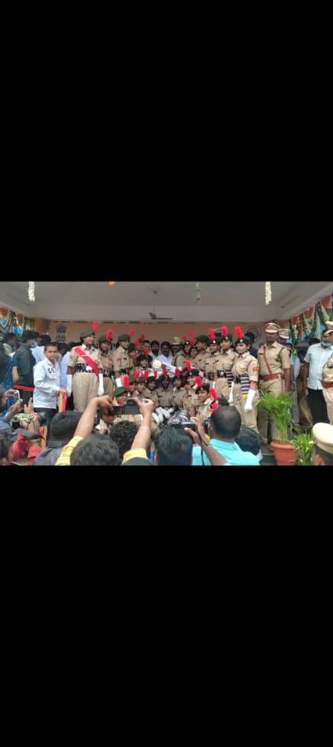
NCC Unit got best parade awards during 76th independence day celebrations at parade grounds kadapa.
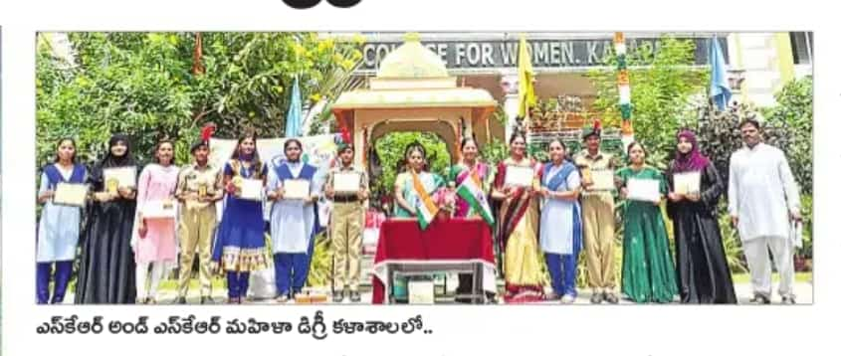 | 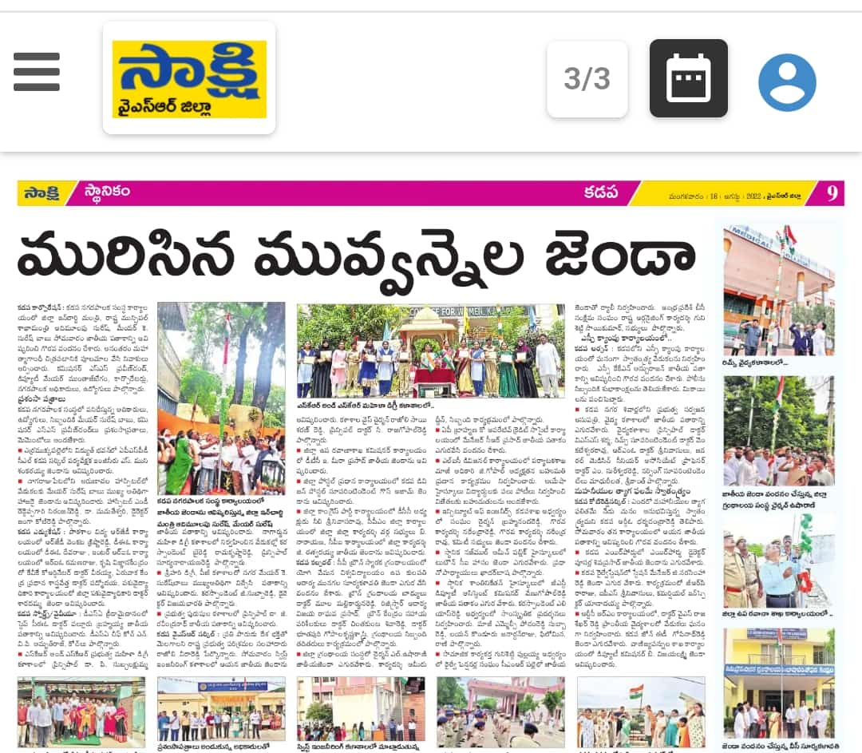
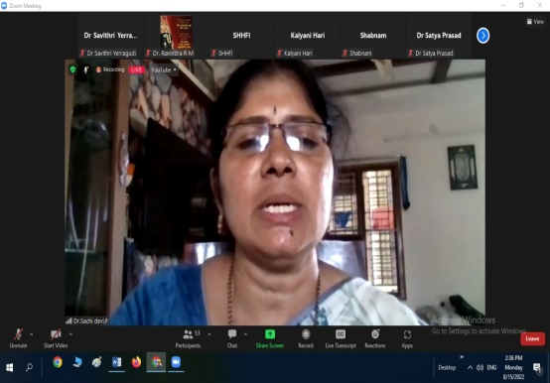 | 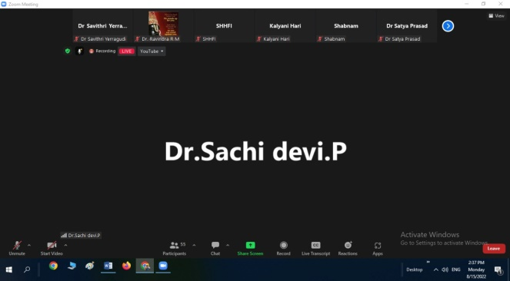
On the occassion of 75 years of Independence Day celebrations Dr P. Sachi Devi, Lecturer in Zoology participated and presented paper on unsung women freedom fighters of India in the International conference on Glory of 75 years Indian independence.

Regional joint director VISIT to the college
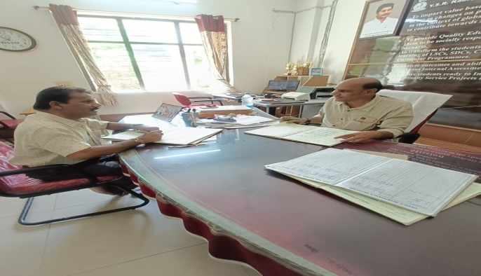 |  | 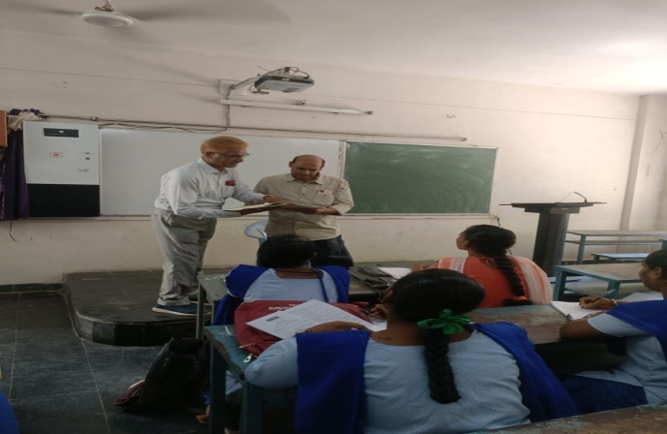
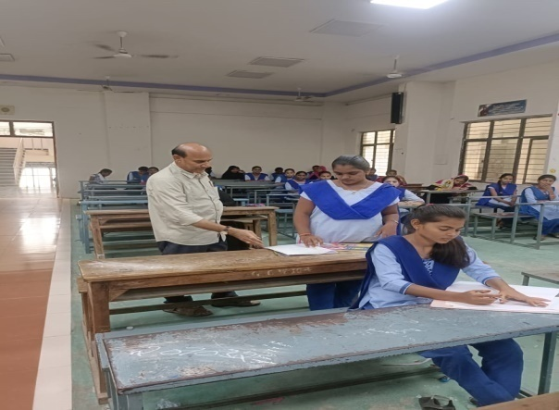 |  | 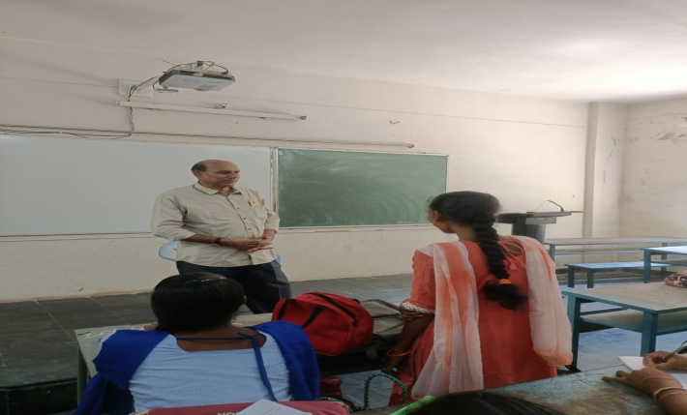
Zone IV RJDCE , Kadapa Dr. D. Nagalinga Reddy sir visited our college on 16.08.2022 and checked the classes, interacted with students and motivated them towards studies. Sir also interacted with staff.
JOB DRIVE 17.08.2022
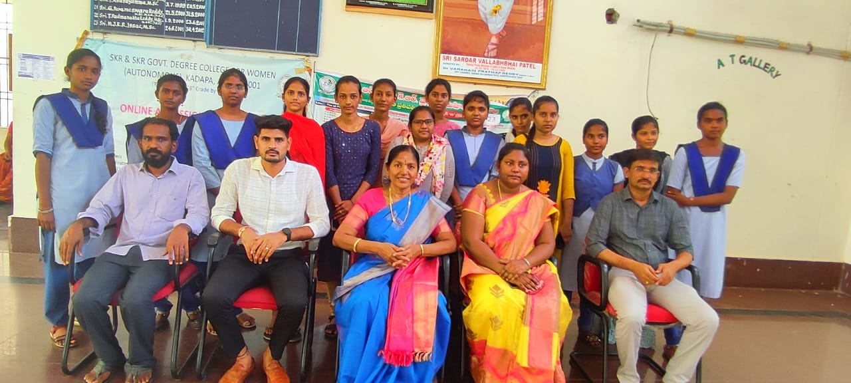 | 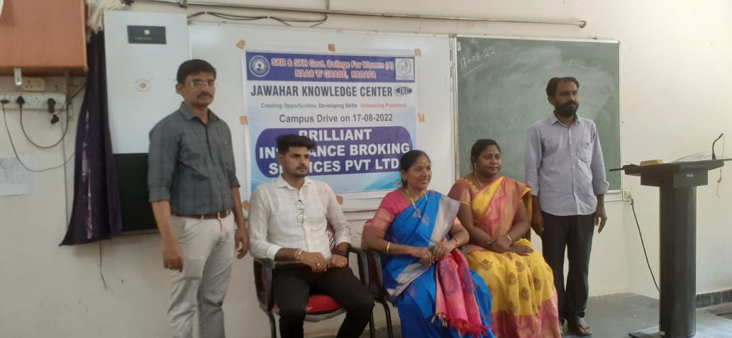
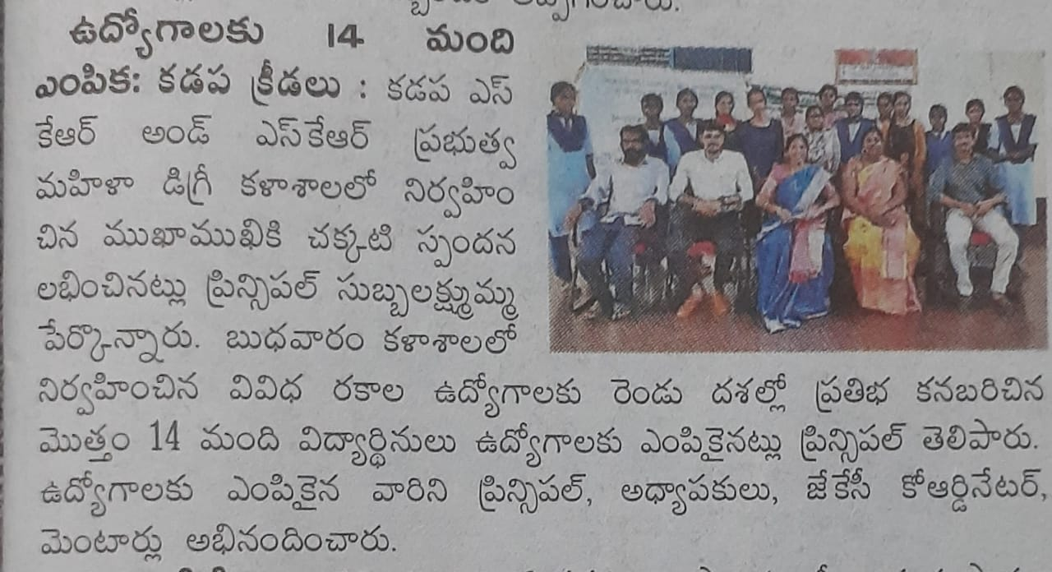 | Jawahar Lal knowledge centre conducted Job drive on 17.08.2022. Dr P. Subba Lakshumma, Principal inaugurated the meeting. Brilliant Insurance Broking Pvt Ltd company interviewed the students 19 students attended to this drive and 14 students selected to the company. Dr P. Sujatha, JKC Coordinator, JKC Mentors participated.

AWARENESS PROGRAMME AND MEDICAL COUNSELLING
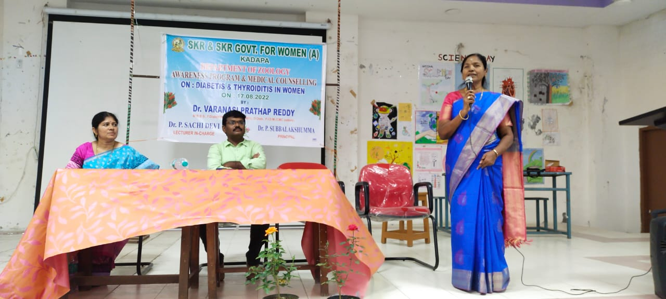 | 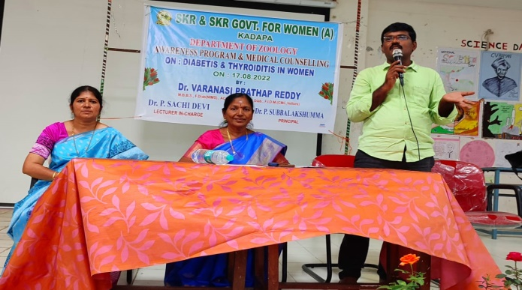
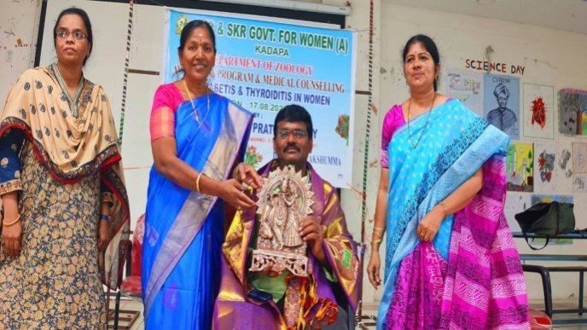 | 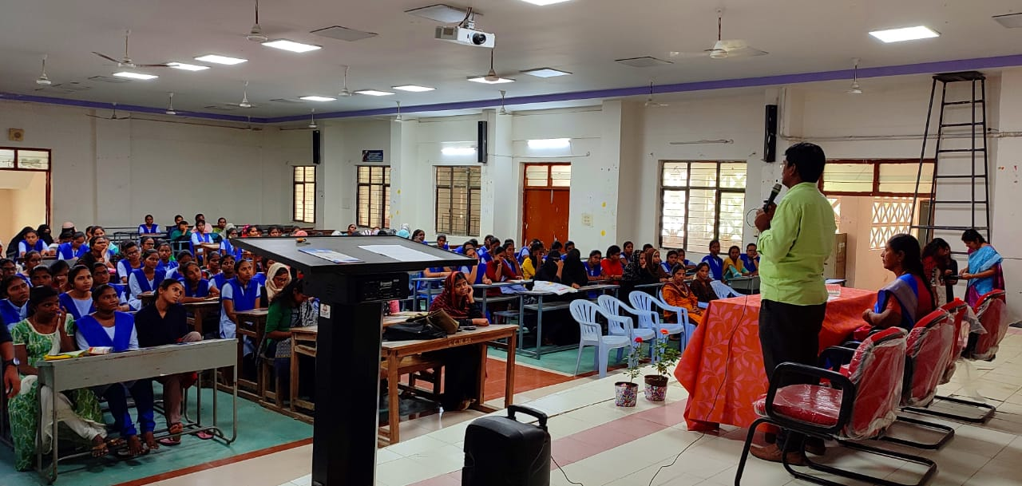
Department of Zoology organsed awareness programme on Diabetes and thyroiditis in women- causes and prevention on 17.08.2022. Dr P. Subba Lakshumma, Principal inaugurated the meeting and created awareness on Diabetes and thyrodidtis among the students. Dr Varanasi Pratap Reddy garu attended as Resource person and explained about the causes and prevention of Diabetes and thyroiditis. Department of Zoology staff and students participated in this programme.

Awareness programme on Solar Energy
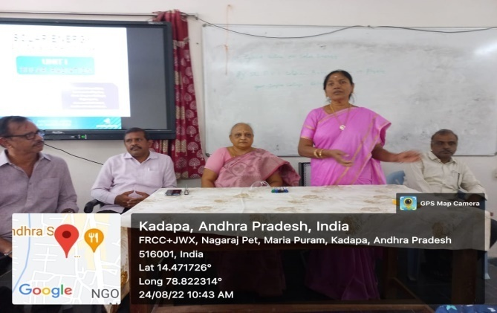 | 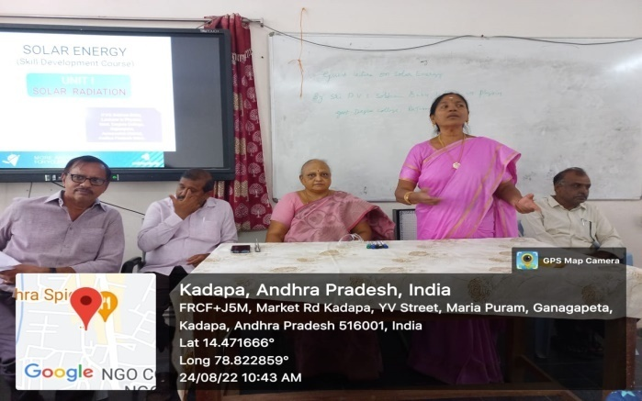
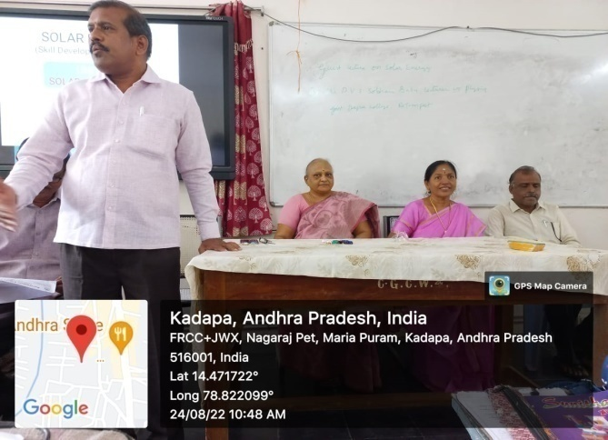 | 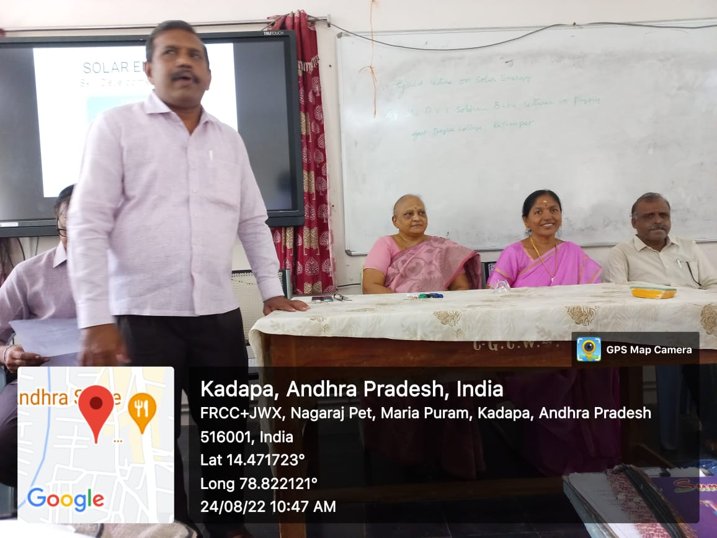
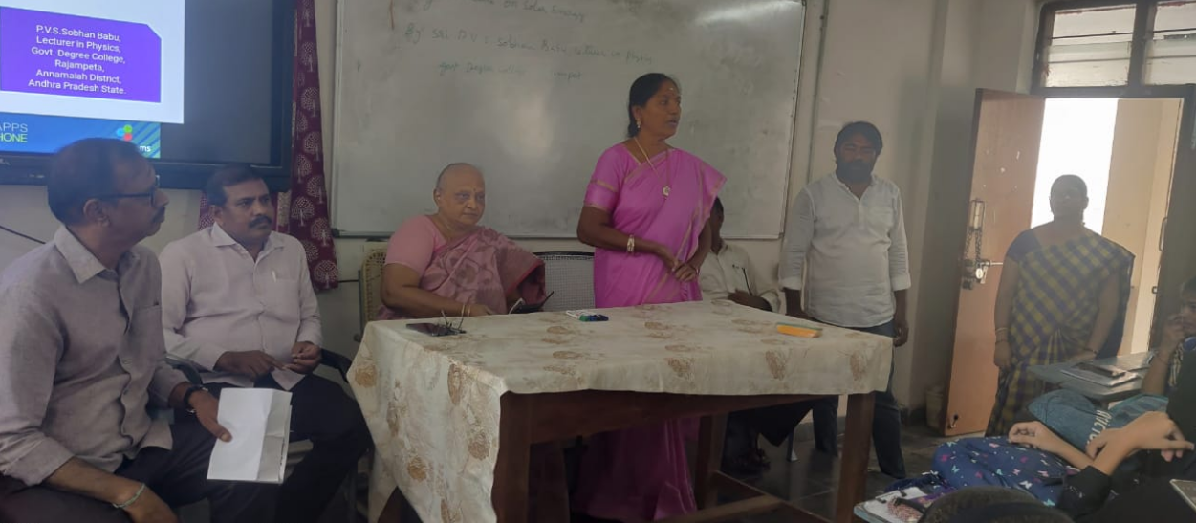 | 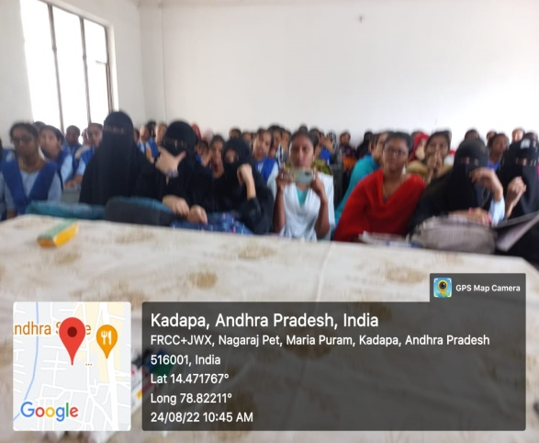
Smt L. Sudheera, Lecturer in Chemistry organised awareness programme on Solar Energy on 24.08.2022. Sri. P.V.S. Sobhan Babu, Lecturer in Physics, GDC Rajampeta, Annamayya Dist attended as resource person and explained about the importance of Solar energy. Dr P.Subba Lakshumma, Principal, Department of Chemistry staff and students participated in this programme.

ACADEMIC AUDIT on 26.08.2022
As per the proceedings of Commissioner of Collegiate Education Academic audit 2020-21 was scheduled on 26.08.2022 and 27.08.2022. Dr M. Ramesh, Dr S. Nagendra, Dr P. Ravi Sekhar, Dr MV Suresh Babu are the Academic Audit Advisors visited the college and Intereacted with Principal, Principal has given presentation on AAA format I College Profile. Team visited all the departments.
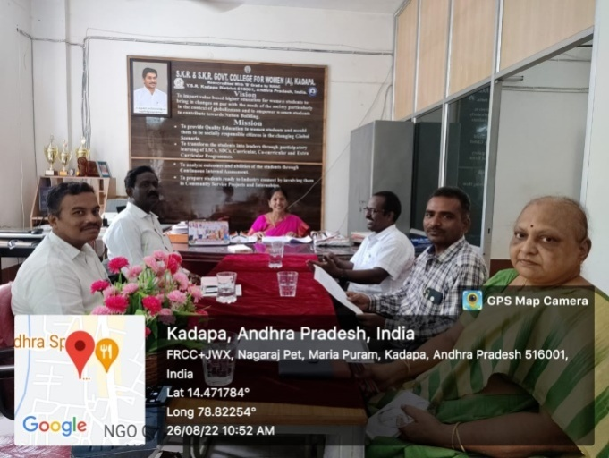  Interaction with Principal |  |  |  | 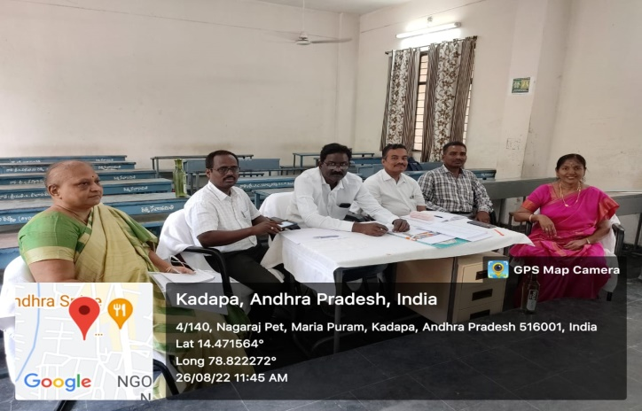  Interaction with Principal
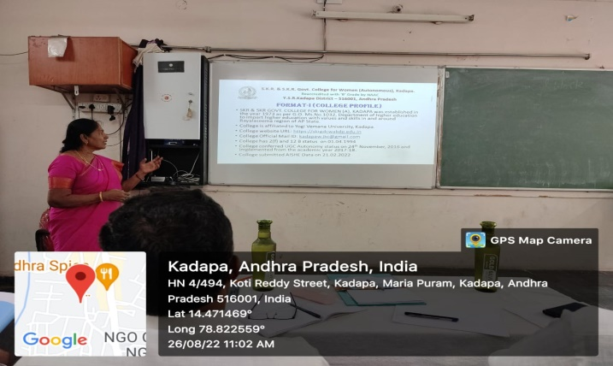  Format I explained by Principal |  |  |  | 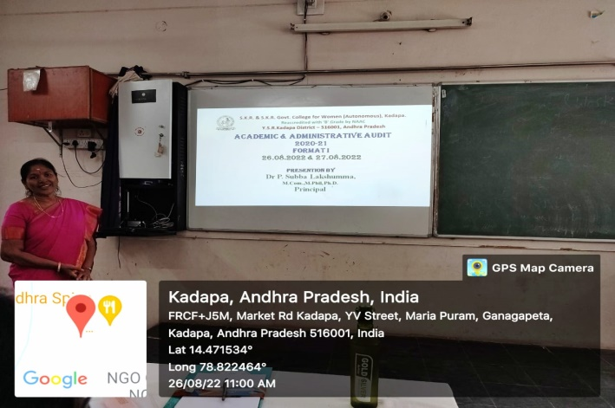  Format I explained by Principal
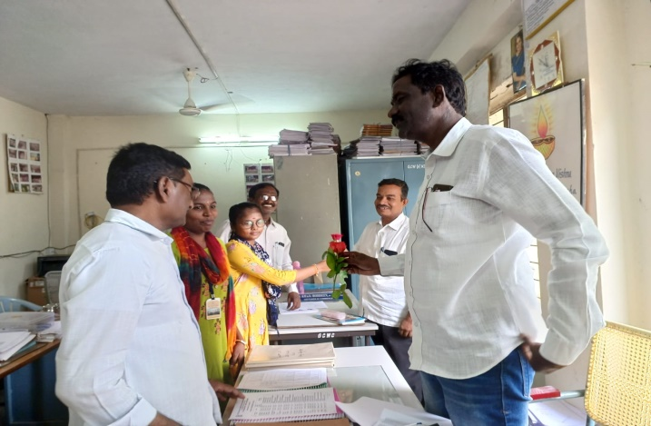  Dept of Commerce |  |  |  | 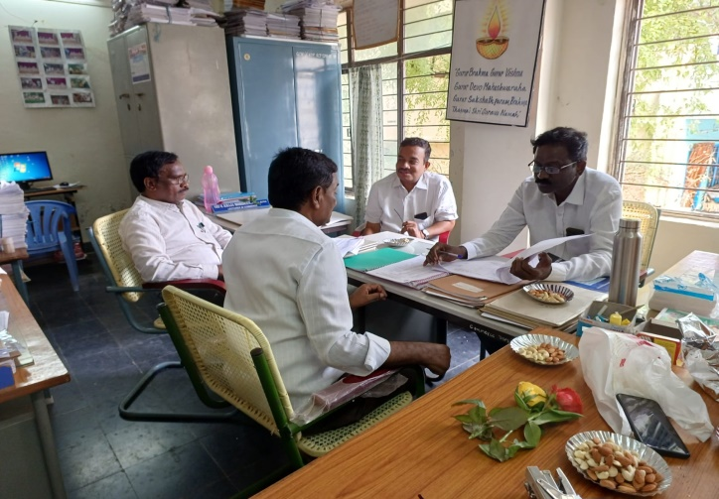Dept of Commerce
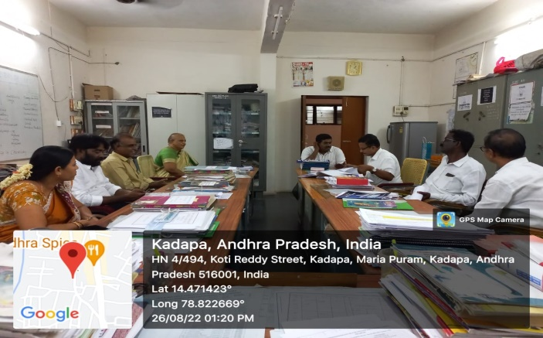  Dept of Chemistry |  |  |  | 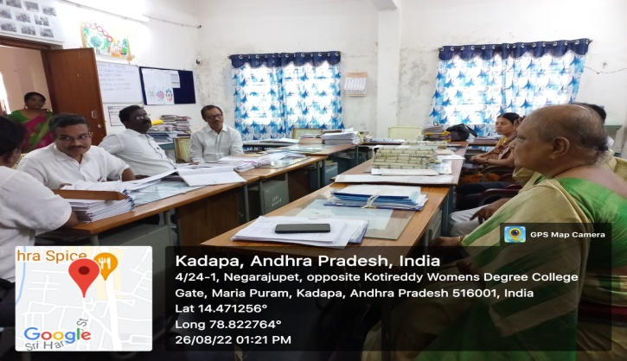  Dept of Chemistry
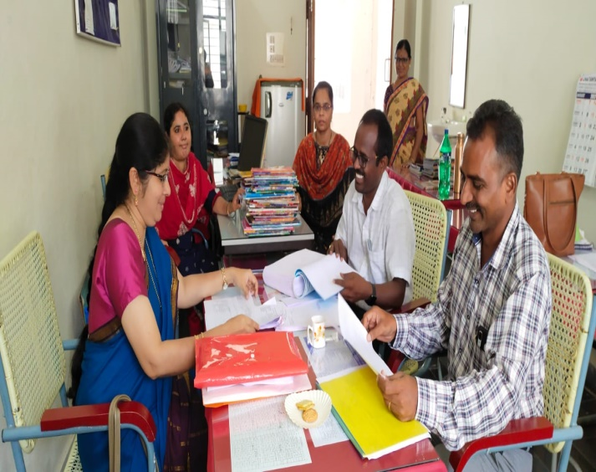  Dept of Zoology |  |  |  | 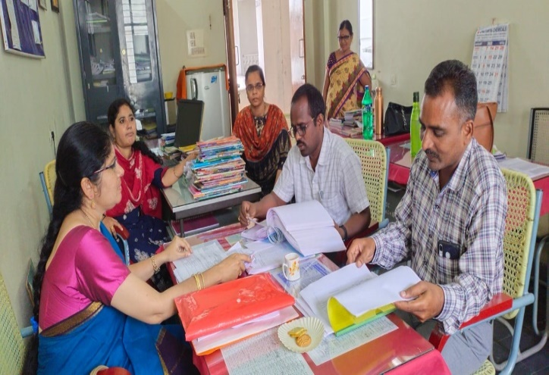  Dept of Zoology
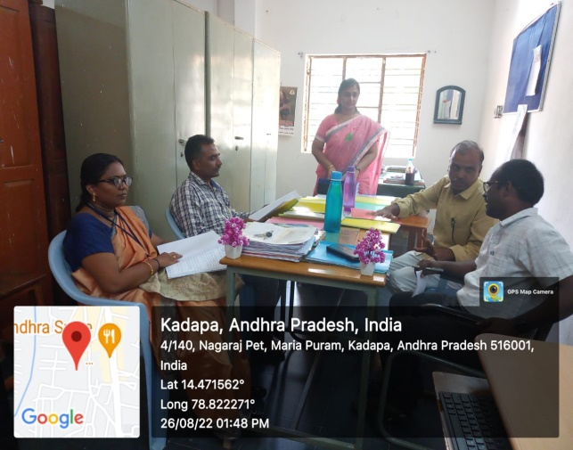  Dept of Biochemistry |  |  |  | 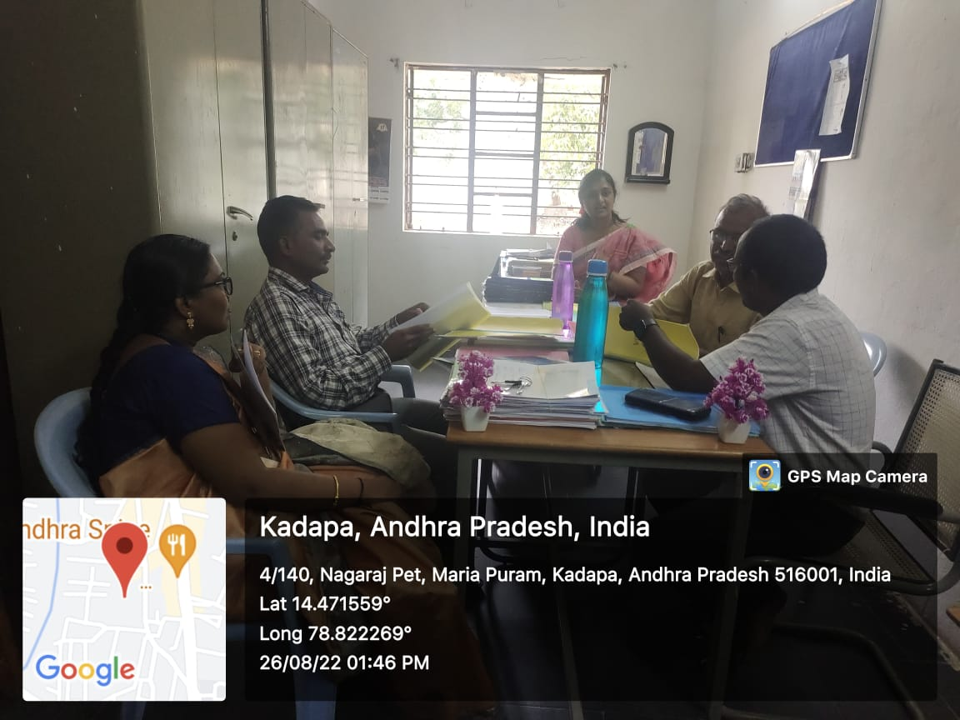  Dept of Biochemistry
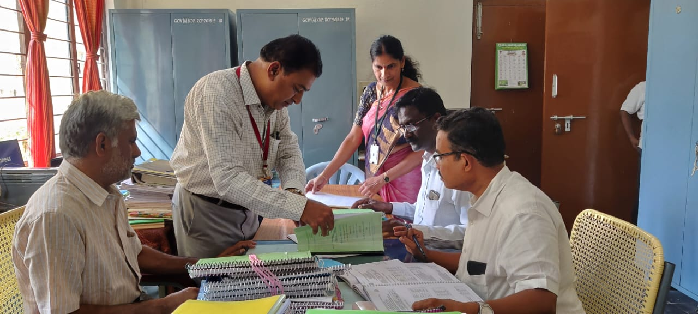  Dept of Economics |  |  |  | 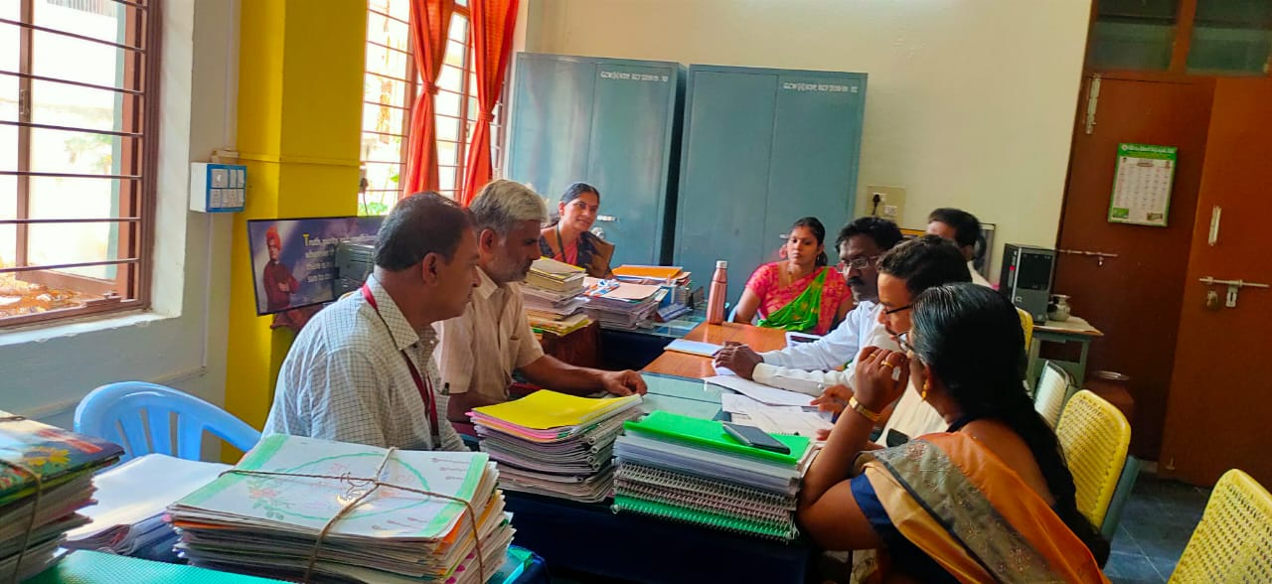  Dept of Economics
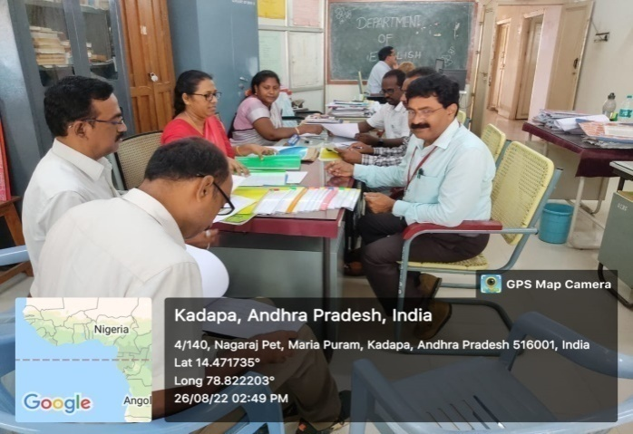  Dept of English |  |  |  |  | 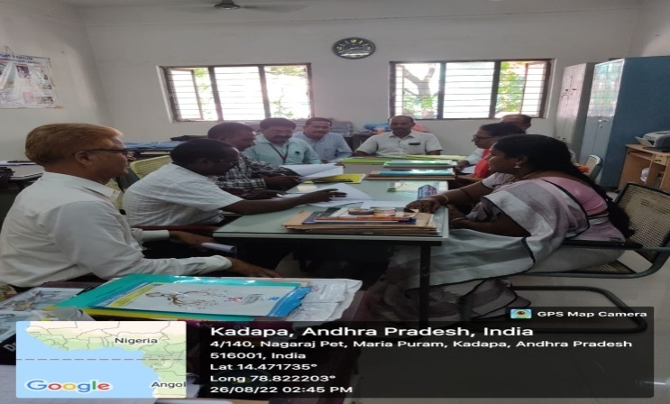  Dept of English
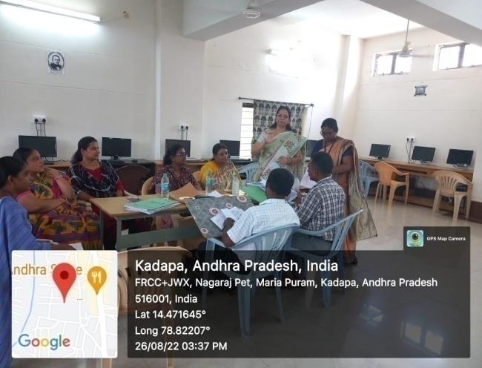  Dept of Computer Science |  |  |  |  | 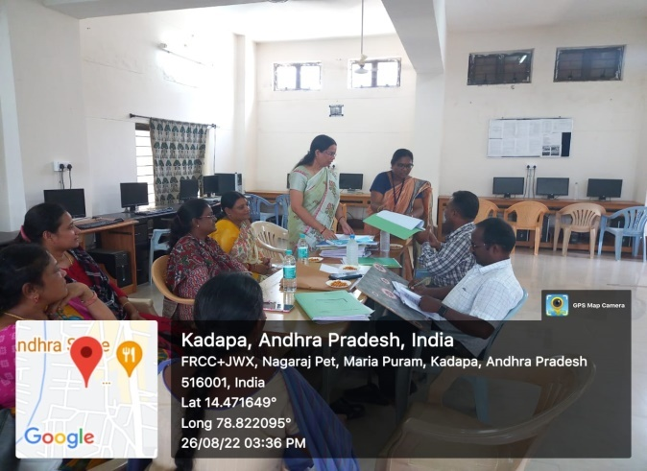  Dept of Computer Science
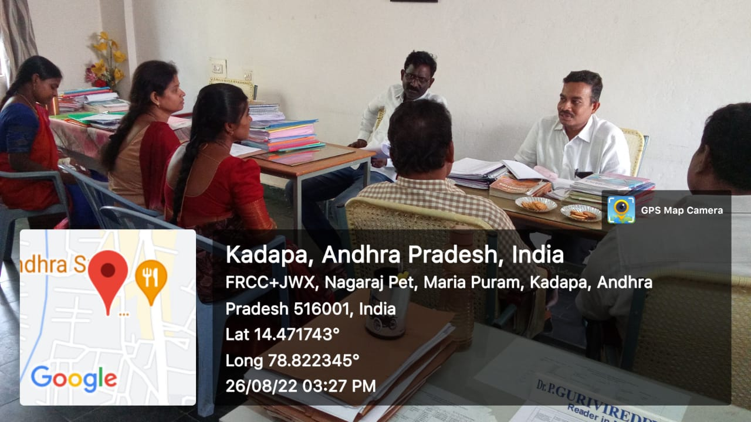  Dept of Mathematics |  |  |  |  | 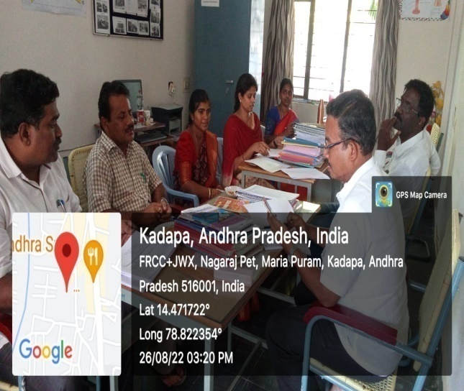  Dept of Mathematics
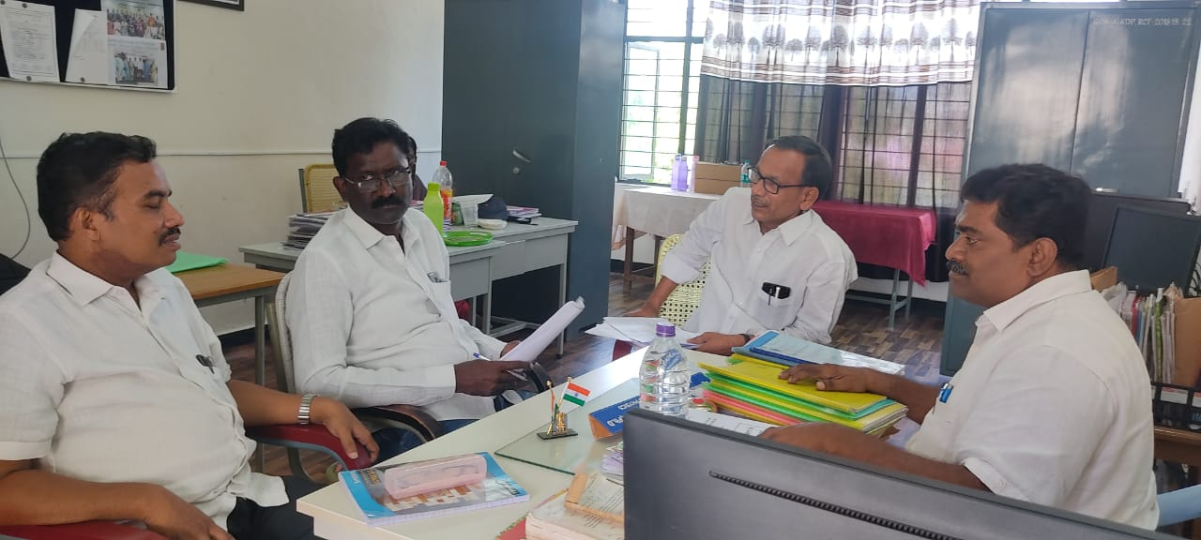  Dept of Physics |  |  |  |  | 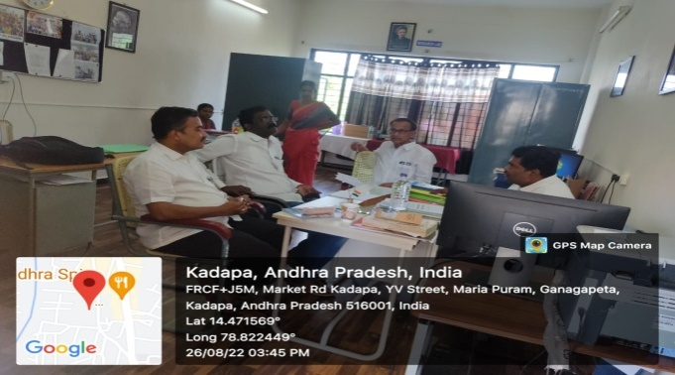  Dept of Physics
 | 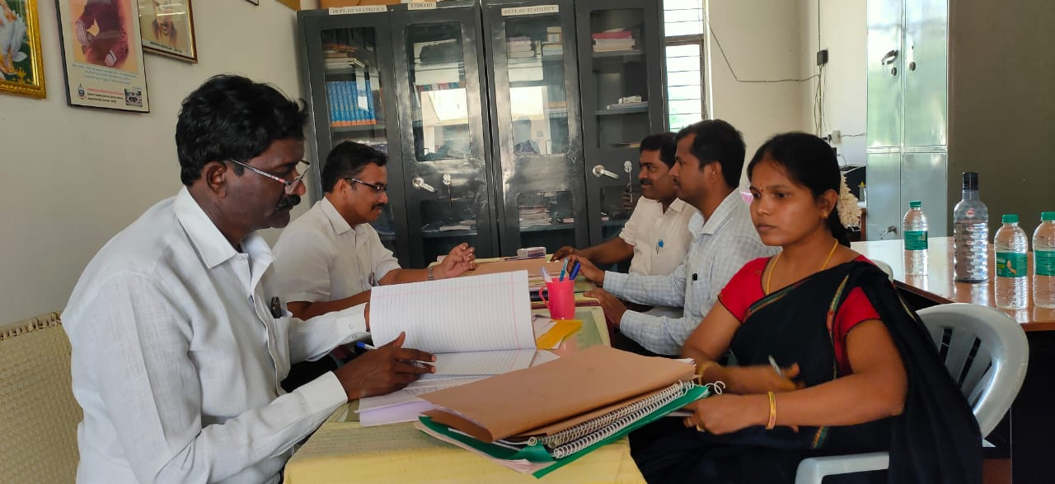  Dept of Statistics |  |  |  |  | 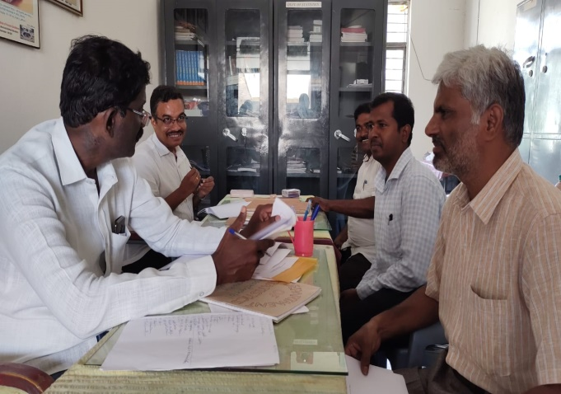  Dept of Statistics
 | 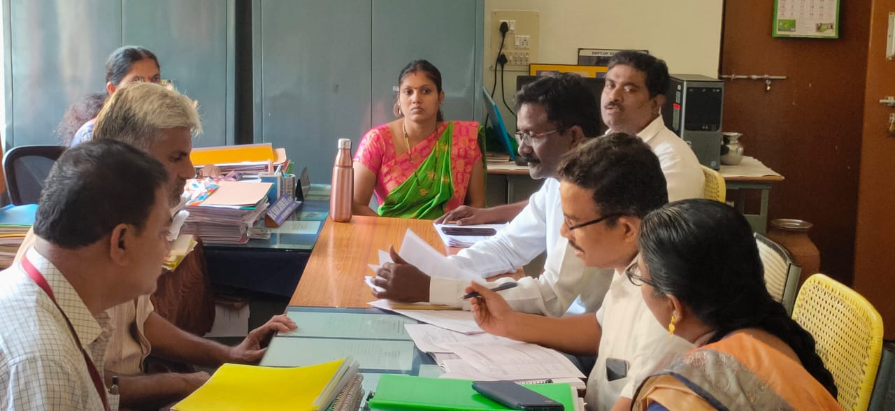  Dept of History |  |  |  |  | 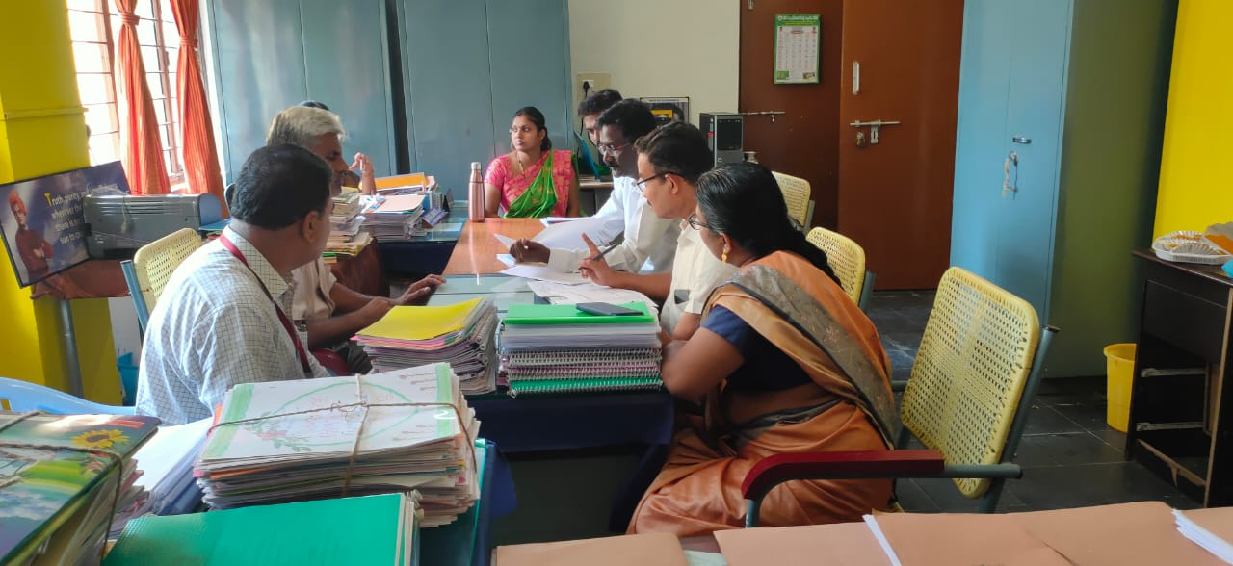  Dept of History
 | 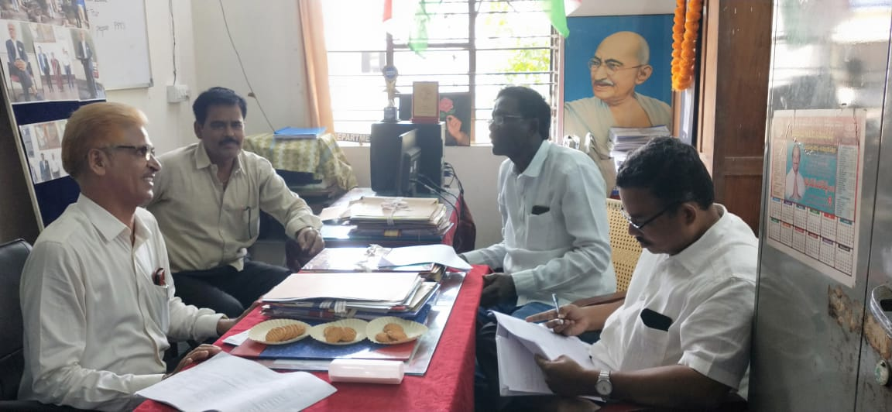  Dept of Political Science |  |  |  |  | 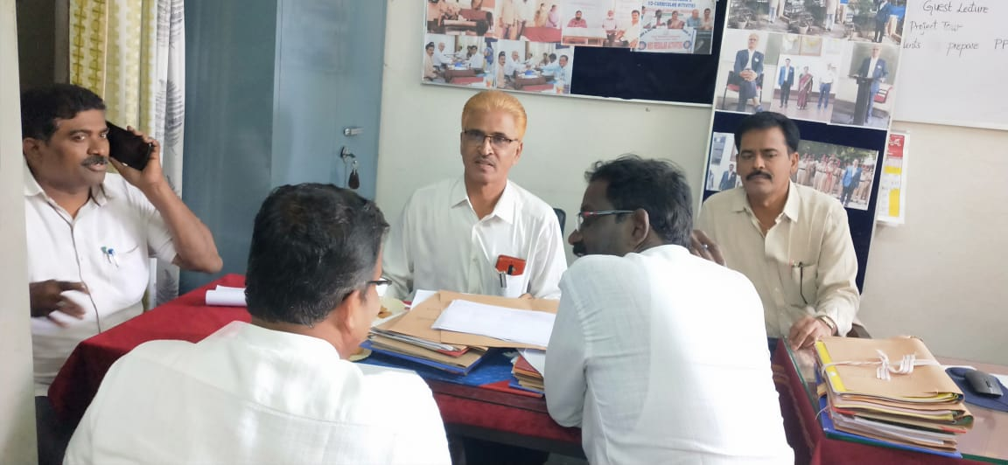  Dept of Political Science
 | 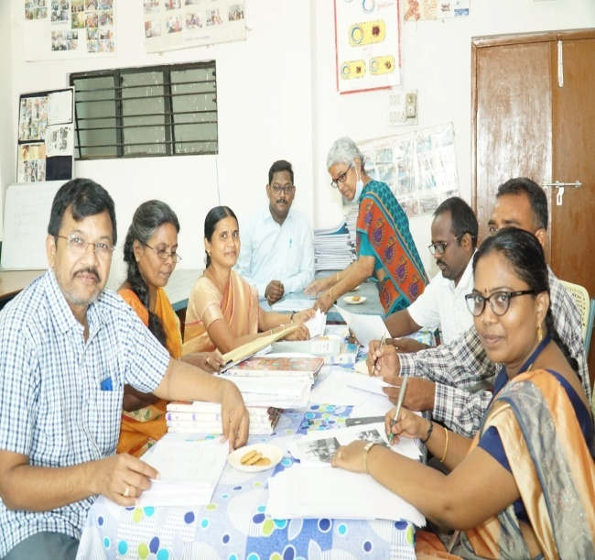  Dept of Botany |  |  |  |  | 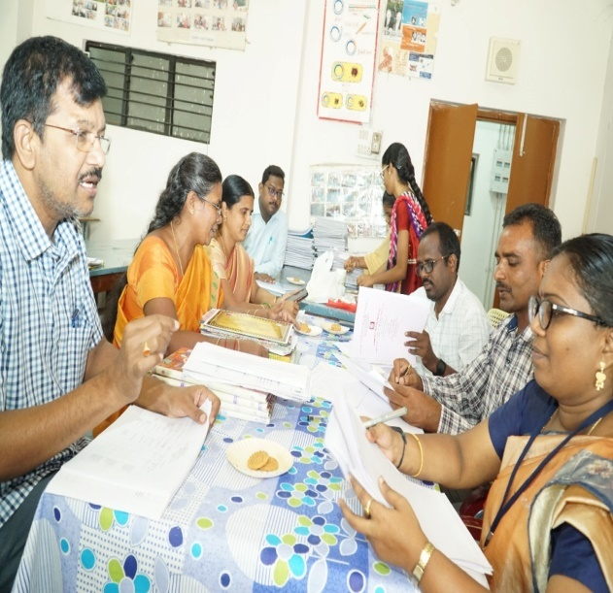  Dept of Botany
 |  | ACADEMIC AUDIT ON 27.08.2022
 |  | Academic Advicers from GCM (A) Kadapa Dr. M. Ramesh, Dr. S. Nagendra, Dr. P. Ravi Sekhar, Dr. MV. Suresh Babu 2nd day visited college. Met with principal. Interaction with NCC officer and NSS Po. Dr C.V Krishnaveni, IQAC Coordinator presented format II presentation.
 |  | 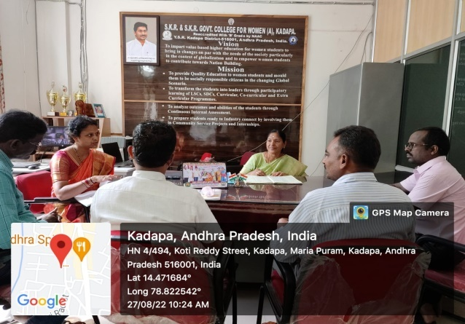 | 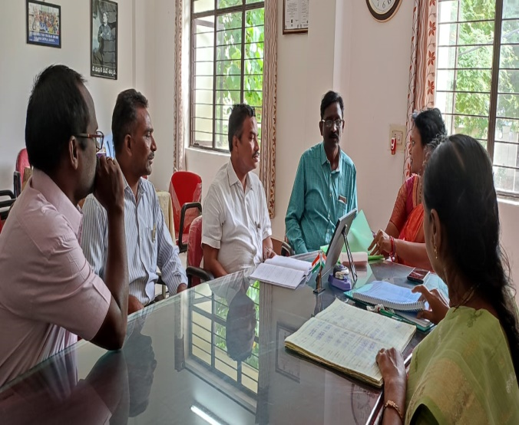
 |  | 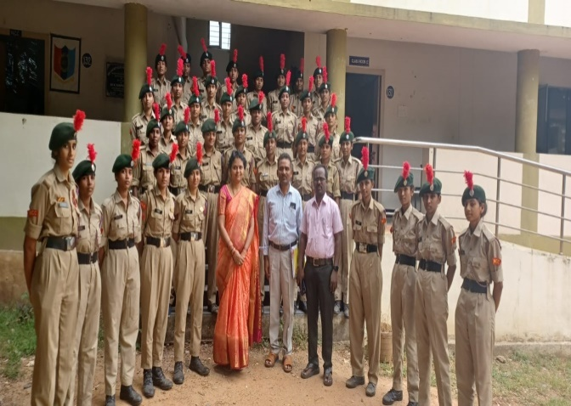  Academic advisors team with NCC Cadets | 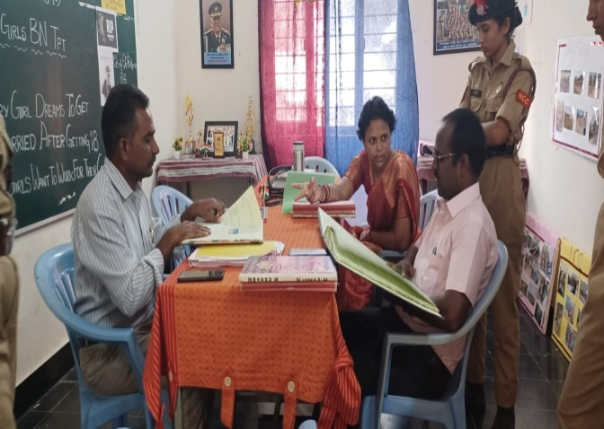  Interaction with NCC Coordinator
 |  | 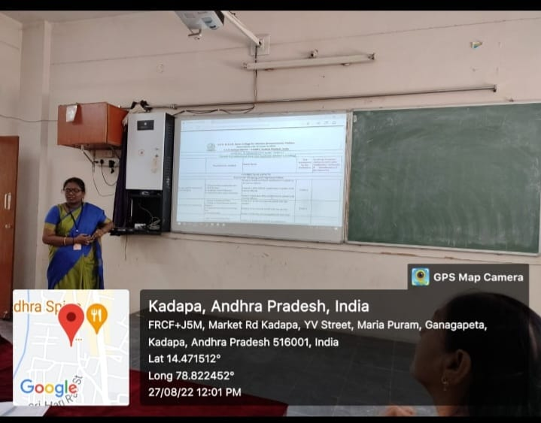  Format II explained by IQAC Coordinator | 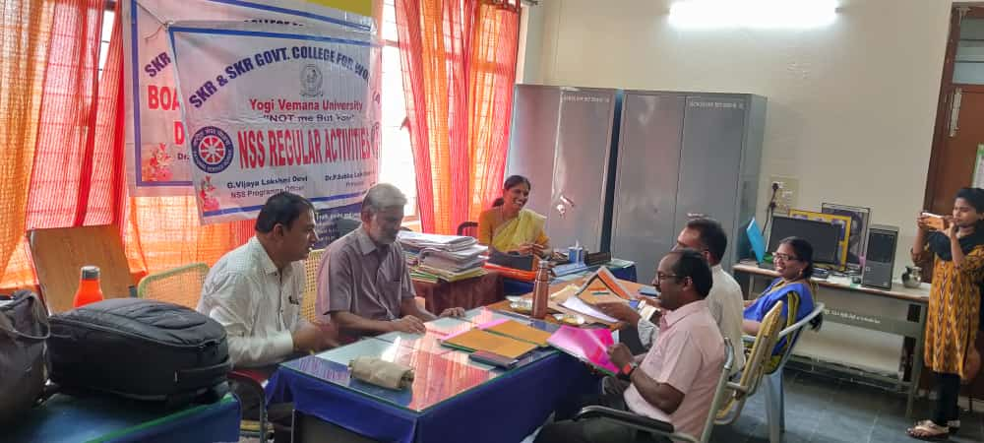  Interaction with NSS Coordinator

EXIT MEETING ON 27.08.2022
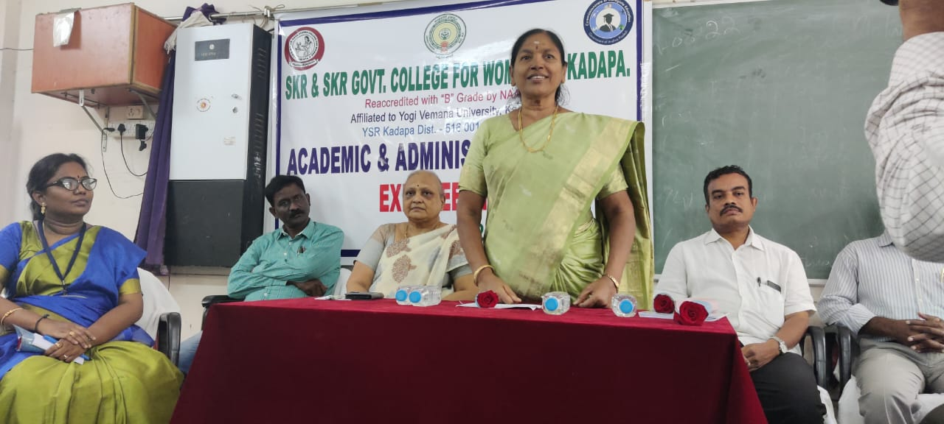 | 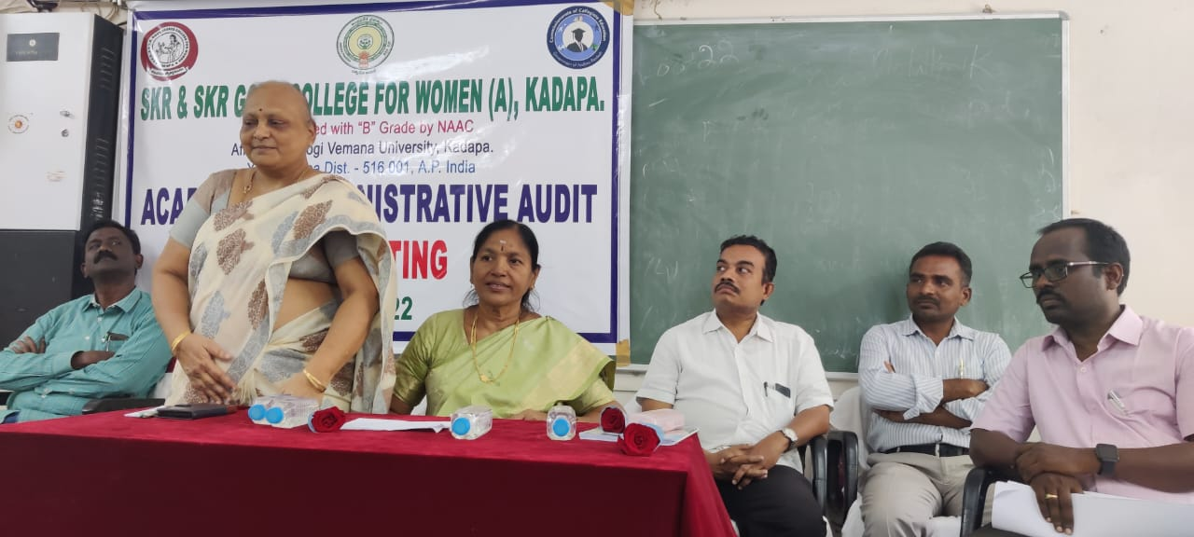
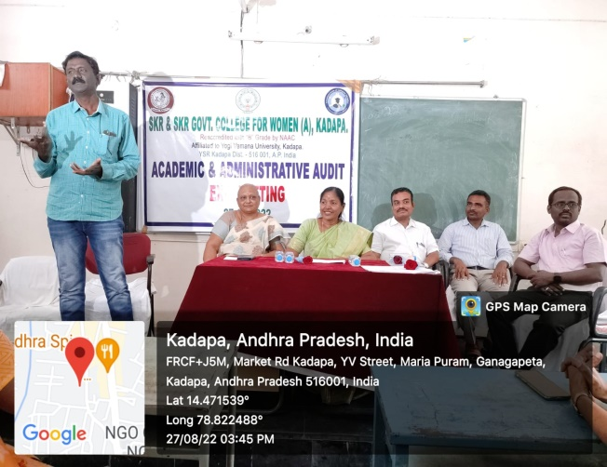 | 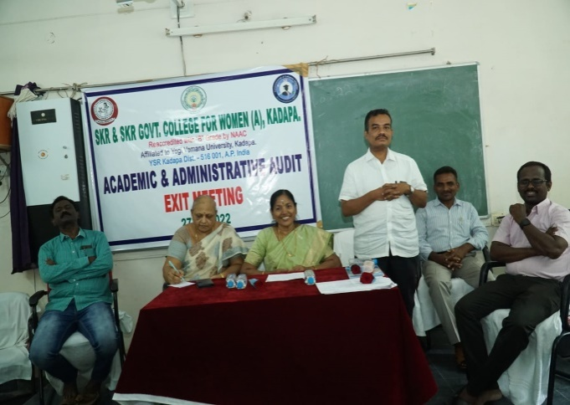
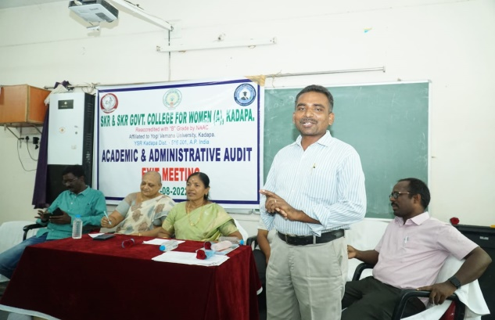 | 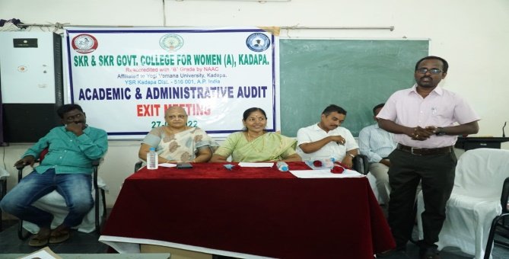
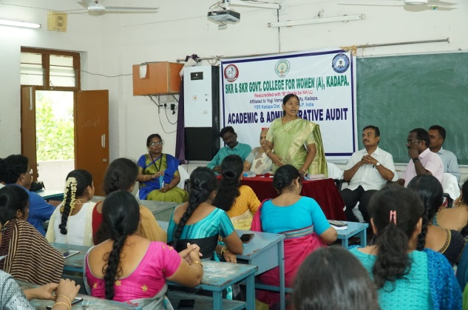 | 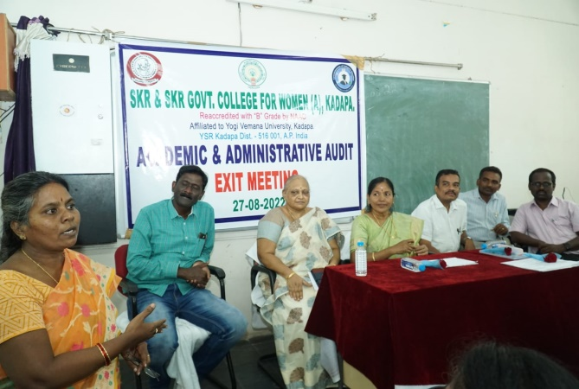
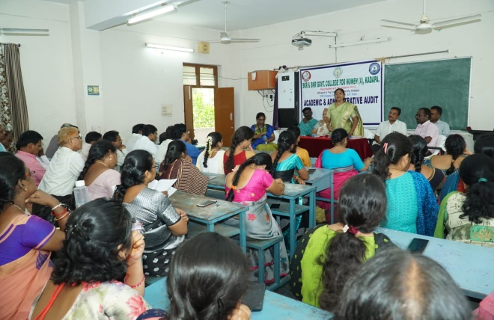 |  | 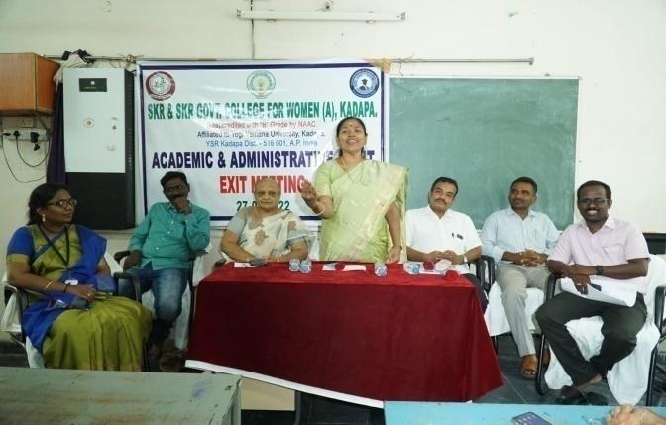
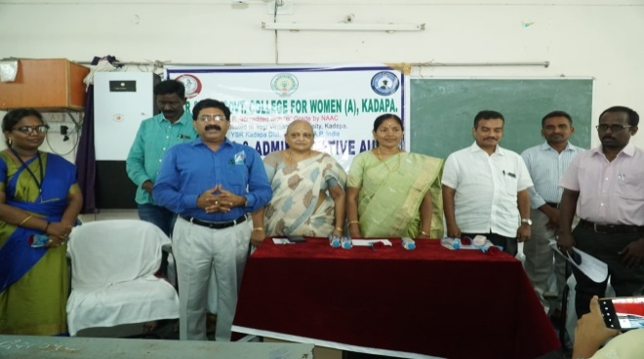 |  | 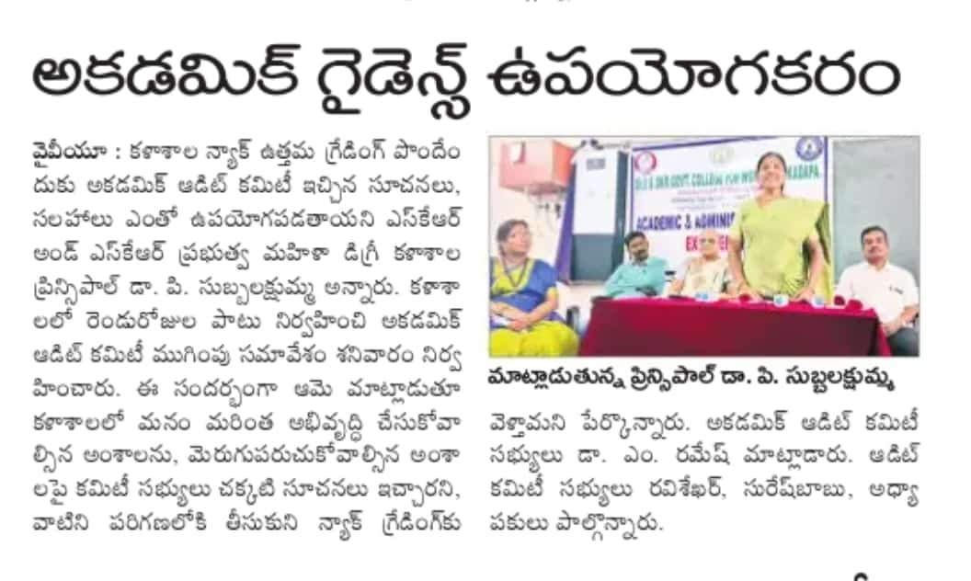

TELUGU BHASHADINOTSAVAM
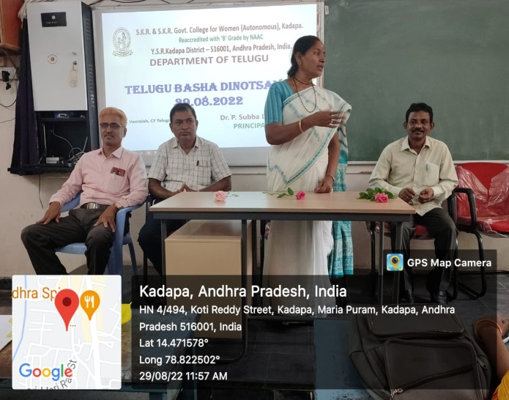 | 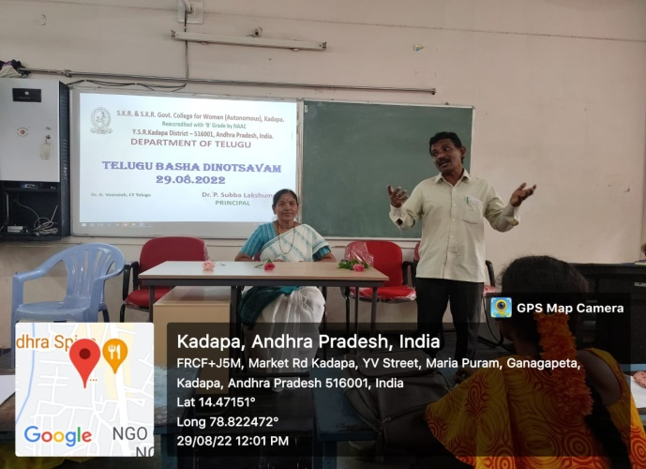
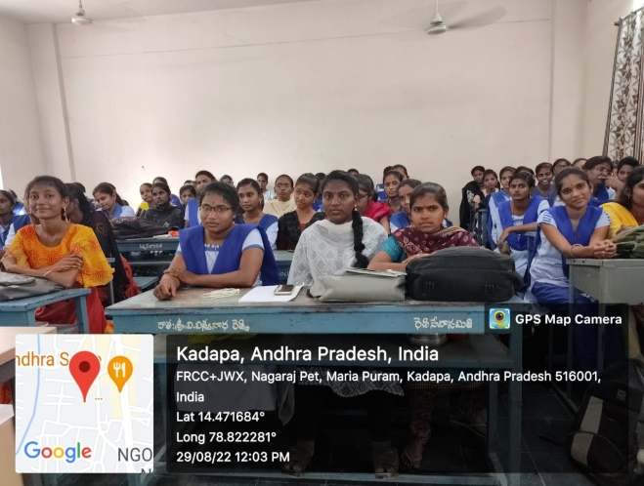 | Dept of Telugu organised Telugu Basha Dinotsavam on 29.08.2022. Dr P. Subba Lakshumma, Principal focused on the contribution of Gidugu Venkata Ramamurthy towards language comprehensible to the common man and Savara language. Dr. Veeraiah, CF in Telugu has spoken the contribution towards Telugu language.

ECO-FRIENDLY CLAY GANESHA IDOL DISTRIBUTION
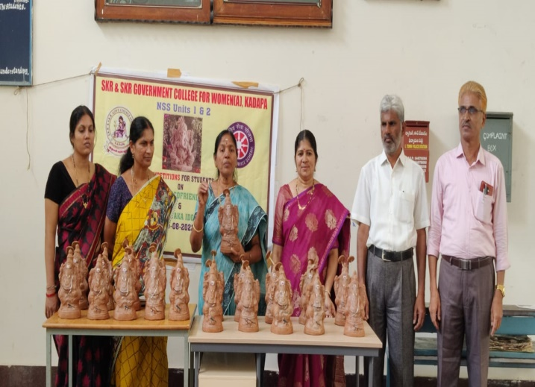 | 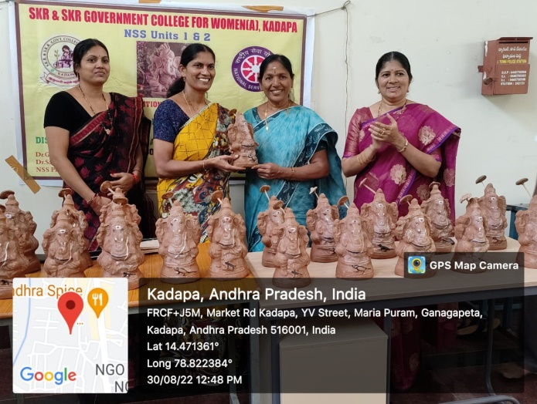
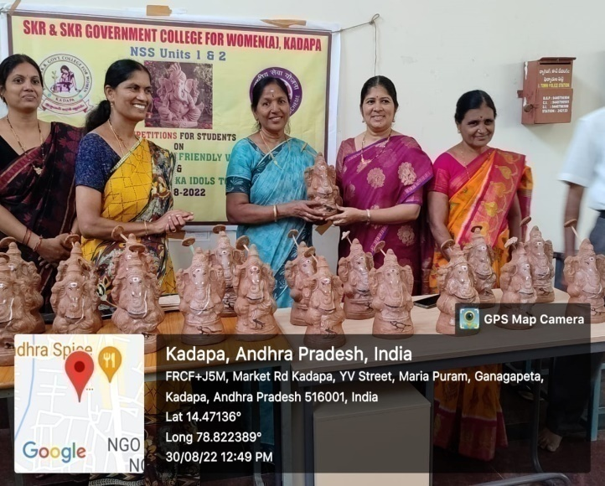 | 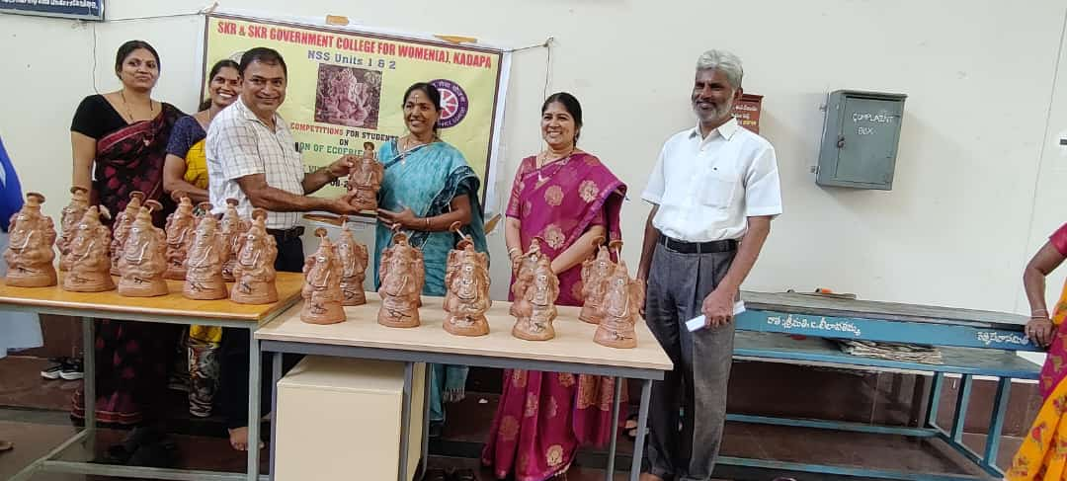
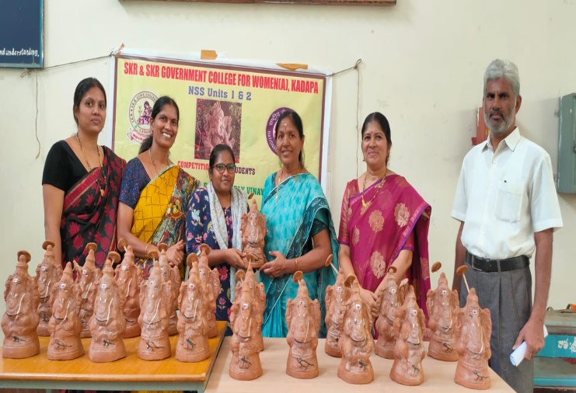 | 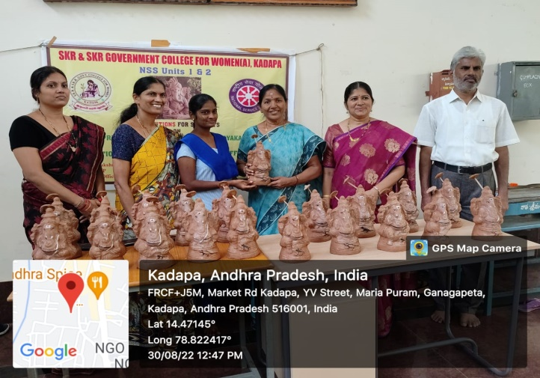
On the occasion of Ganesh Festival celebrations Dr P. Subba Lakshumma, Principal distributed Clay Ganesha Idols to staff and students on 30.08.2022.

Prepared by:  K.Shalini,  Department of Mathematics,  SKR& SKR Govt. College for women(A),  Kadapa | Edited by:  Dr P.Subba Lakshumma,  Principal,  SKR& SKR Govt. College for Women(A).  Kadapa.

